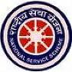
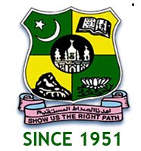
JAMAL MOHAMED COLLEGE
(AUTONOMOUS) College with potential for Excellence
Accredited (3rd Cycle) with ‘A’ Grade by NAAC
(Affiliated to Bharathidasan University)
Tiruchirappalli-620 020
NATIONAL SERVICE SCHEME
REGULAR ACTIVITY
FRESHER’S DAY
On the date of 18th June 2018, the Fresher’s Day programme was celebrated by the Management of Jamal Mohamed College. The grand Inauguration function took place at The A/C Auditorium of Jamal Mohamed College by 09.00 a.m. The entire fresher’s were warmly welcomed by the Management and Staff members and the students. Sweets were distributed for the fresher’s.

Number of NSS Volunteers Participated: 10 DATE :18/06/2018
VENUE : A/C AUDITORIUM
HOURS :3 hrs TIME : 9:00 AM to 12:00 PM
CHIEF GUEST : A
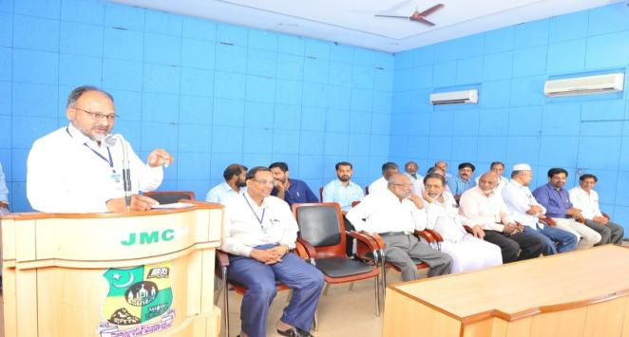
INTERNATIONAL DAY OF YOGA CELEBRATIONS @ BHARATHIDASAN UNIVERSITY

On the date of 21/06/2018, The International Day of Yoga was celebrated by the NSS Cell of Bharathidasan University in association with the NSS units of other colleges in Kajamalai Campus at Bharathidasan University.
He did many Yoga Postures and also made the volunteers do some easy postures. The programme was a mass success because of the co-ordination of volunteers.

Number of NSS Volunteers Participated:40 DATE :21/06/2018

VENUE : KHAJAMALAI BDU CAMPUS
HOURS :3 hr TIME : 6:30 AM to 9:30 AM
CHIEF GUEST: GANESAN
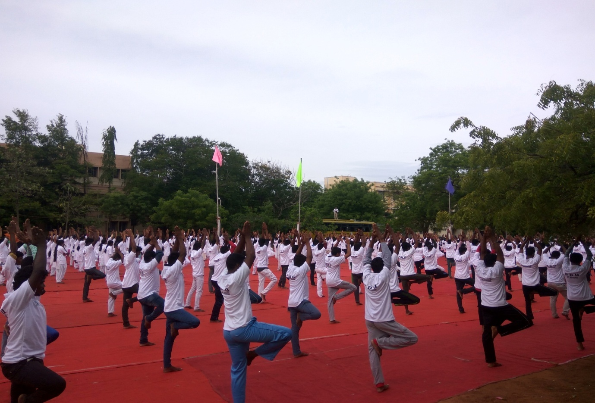
INTERNATIONAL DAY OF YOGA CELEBRATIONS @ NEHRU YUVA KENDRA
On the date of 21/06/2018, International Yoga Day was celebrated by Nehru yuva Kendra sangathan in association with the NSS units of other colleges in Youth Hostel, Khajamalai, Tiruchirappalli.
He did many Yoga Postures and also made the volunteers do some easy postures.

Number of NSS Volunteers Participated:35 DATE :21/06/2018

VENUE : Youth Hostel
HOURS :1 hrs TIME : 9:30 AM to 10:30 AM
CHIEF GUEST : SUBRAMANIYAN

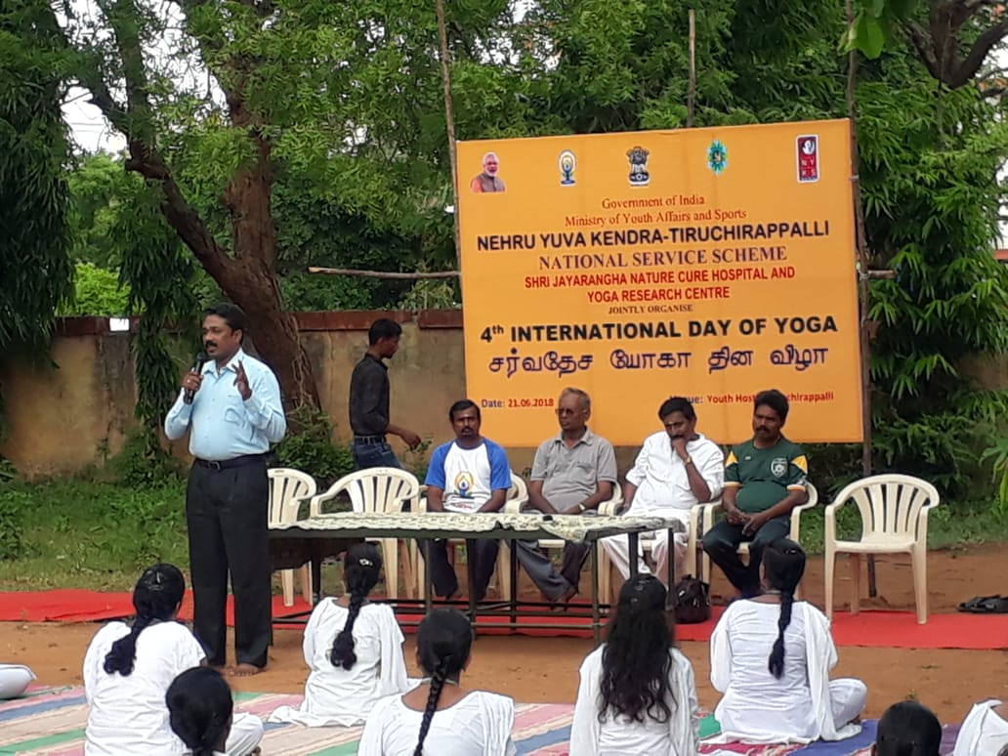

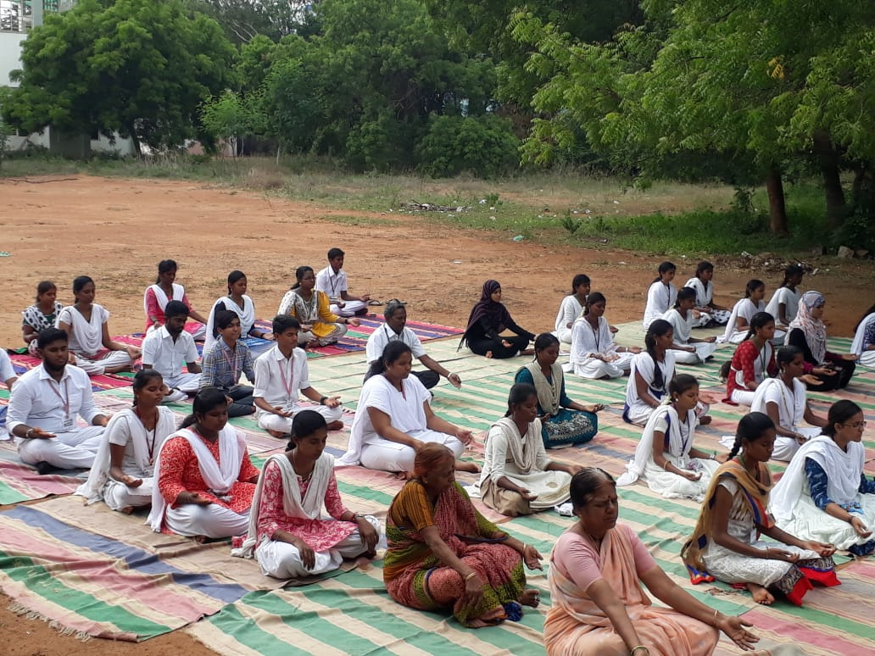
INTERNATIONAL DAY OF YOGA @ JAMAL MOHAMED COLLEGE

On the date of 21/06/2018, The International Day of Yoga was celebrated by Our College, organized by NSS Units of JMC at Multi Purpose Indoor stadium of our campus.

Number of NSS Volunteers Participated::200 DATE :21/06/2018
VENUE : INDOOR STADIUM, JMC
HOURS :1 hrs TIME : 10:00 AM to 11:00 AM
CHIEF GUEST : GANESAN

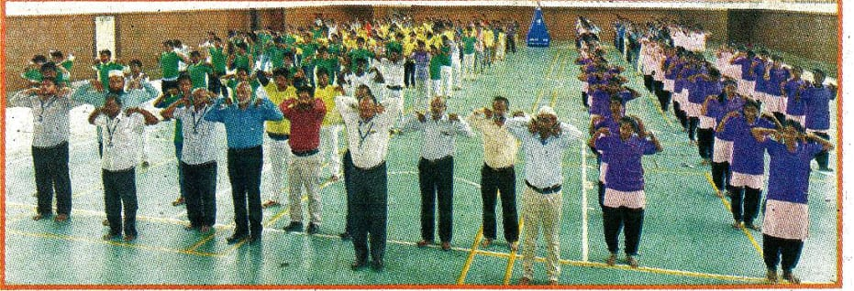

TOBBACO AWARENSS

On the date of 26th june 2018 , tobbaco Awareness programme was . And also awaking our Trichirapalli people those are have and good experience. It is a excellent camp and helpful camp for Trichirapalli people. The programme was great success.

Number of NSS Volunteers Participated: 34 DATE :26/06/2018
VENUE : Vestrey’s school
HOURS : 3 hrs TIME : 08:30 AM to 11:30 AM
CHIEF GUEST : COLLECTOR RAJAMANI

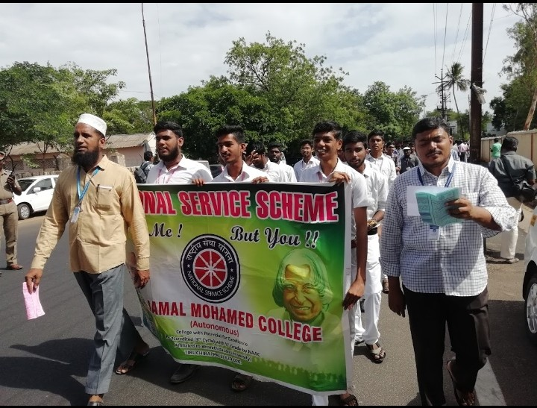

JOB FAIR PROGRAMME

On the date of 30/06/2018, JOB FAIR PROGRAMME was celebrated by the NSS VOLENTEER’S in JAMAL MOHAMED COLLEGE at COMPUTER SCIENCE SEMINAR HALL
The programme was a mass success because of the co-ordinator of volunteers.

NO. OF PARTICIPANT :20 DATE :30/06/2018
VENUE : C.S seminar hall , College campus
HOURS :6 hrs TIME : 09:00 AM to 3:00
CHIEF GUEST :KUMARAN

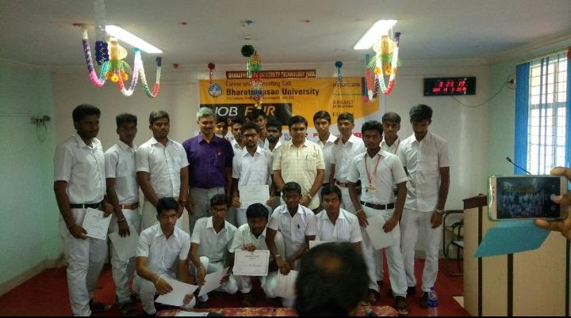

WORLD POPULATION DAY – OATH

On the date of 11/07/2018, WORLD POPULATION DAY – OATH was taken by our NSS VOLENTEER’S along with Faculty members in front of Auditorium of Our College.
Number of NSS Volunteers Participated: 100 Date: 11.07.2018
CHIEF GUEST : THE SECRETARY,PRINCIPAL& TRESURER

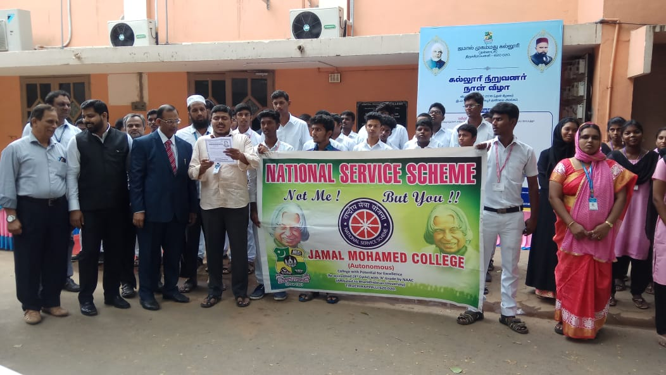

WORLD POPULATION DAY – RALLY

On the date of 11/07/2018, WORLD POPULATION DAY – RALLY was organized by Government of Tamilnadu, at Tiruchirappalli, Our 50 NSS VOLENTEER’S took part in this Rally from Vestry’s School to Government Medical College Campus.
Number of NSS Volunteers Participated: 50 Date: 11.07.2018
VENUE : Vestry’s School
HOURS :3.00 hrs
TIME : 08:30 AM to 11:30 AM
CHIEF GUEST: COLLECTOR RAJAMANI
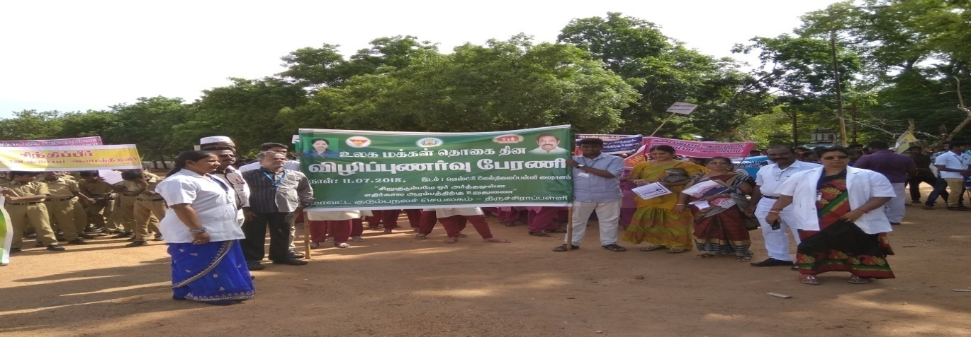

AADITHAR MEMORIAL NATIONAL
SEMINAR

On the date of 12/07/2018, AADITHAR MEMORIAL NATIONAL SEMINAR was attended by the NSS VOLENTEER’S in Bharathidhasan University , Trichy.
The programme was a mass success because of the co-ordinator of volunteers.
NO. OF PARTICIPANT : 32 DATE :12/07/2018
VENUE : BHARATHIDHASAN UNIVERSITY
HOURS :06.00 hrs TIME : 09:30 AM to 03:30 PM
CHIEF GUEST : BDU VICE CHANCELLOR MANI SELVAN
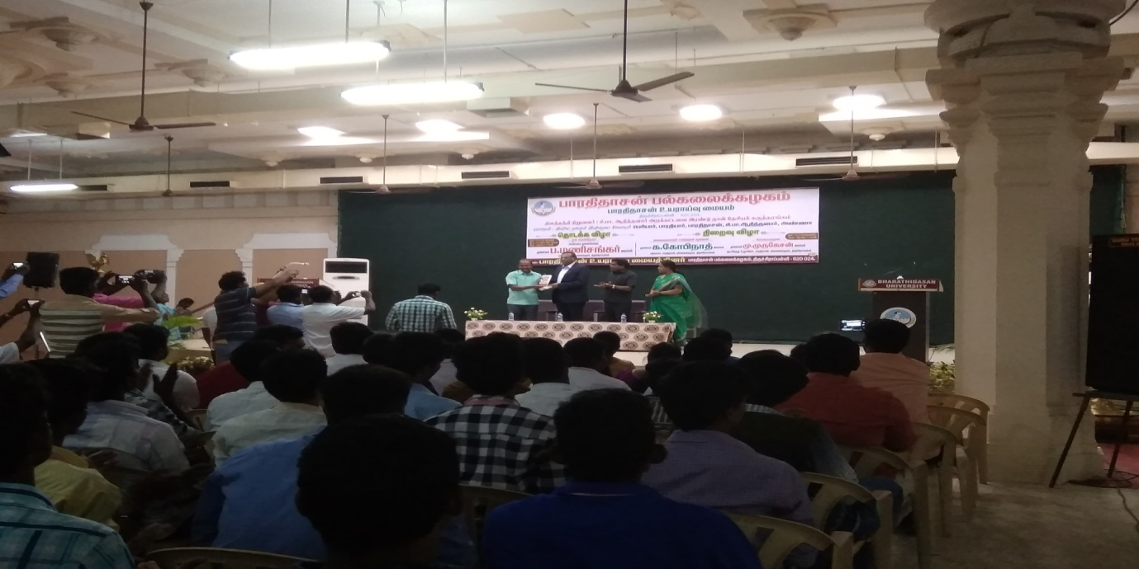

ONE DAY FREE EYE CHECKUP CAMP

On the date of 13/07/2018, One Day Free EYE CHECKUP CAMP was Organized by Our NSS Units Jointly with Joseph’s Eye Hospital at Computer Seminar Hall, JMC Campus, Tiruchirappalli.

Number of NSS Volunteers Participated: 15 Number of Benifecieries:150
VENUE : Computer Science Seminar Hall. DATE :13/07/2018
HOURS :04.00 hrs TIME : 09:30 AM to 01:30 PM
CHIEF GUEST: THE SECRETARY,PRINCIPAL& TRESURER
``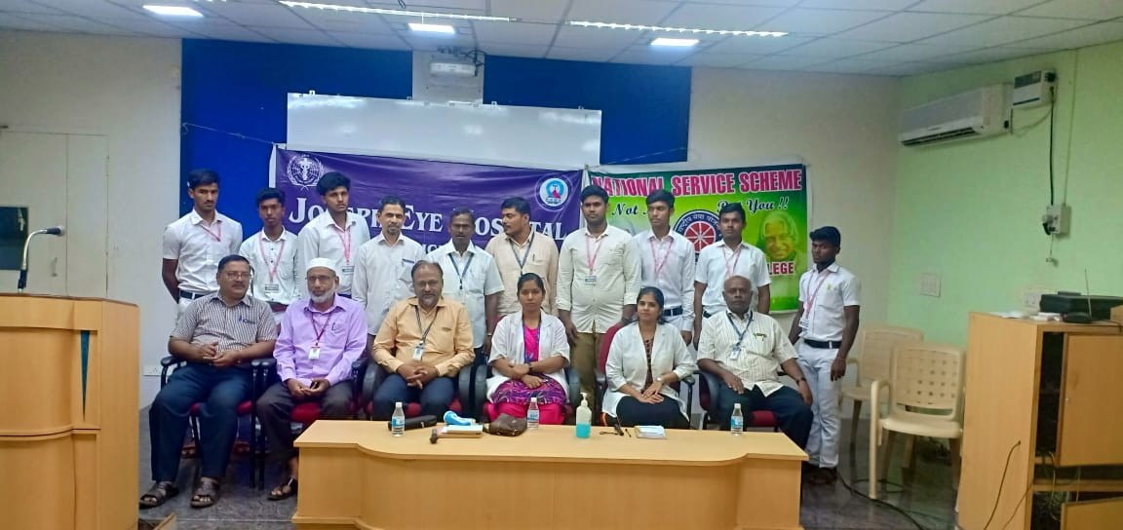

INAUGURAL FUNCTION

On the date of 27/07/2018, INAGURAL FUNCTION was celebrated by the NSS VOLENTEER’S in Hussainudeen hall .

The programme was a mass success because of the co-ordinator of volunteers.

NO. OF PARTICIPANT : 120 DATE :27/07/2018
VENUE : Hussainudeen hall
HOURS :04.00 hrs TIME : 09:00 AM to 01:00 PM
CHIEF GUEST : PRASSANA BALAJI
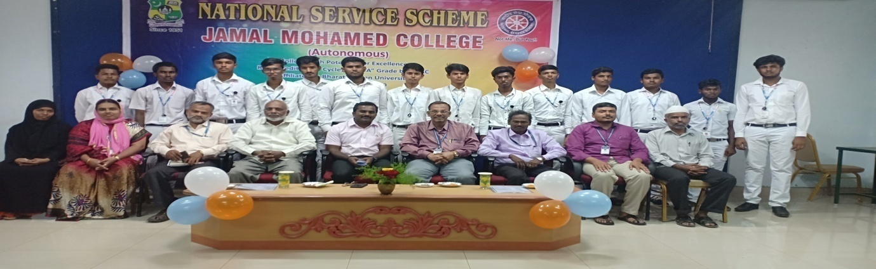
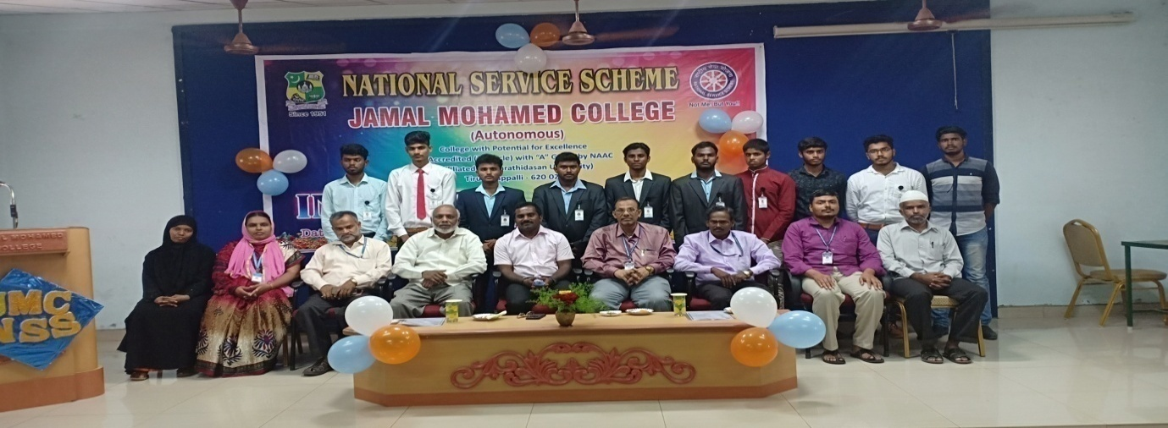

SPORTS DAY FUNCTION

On the date of 01/08/2018, SPORTS DAY FUNCTION was celebrated by the NSS VOLENTEER’S in JMC , College ground.

The programme was a mass success because of the co-ordinator of volunteers.

NO. OF PARTICIPANT : 120 DATE :01/08/2018
VENUE : JMC , College ground
HOURS :04.45 hrs TIME : 08:45 AM to 01:30 PM
CHIEF GUEST: THE SECRETARY,PRINCIPAL& TRESURER
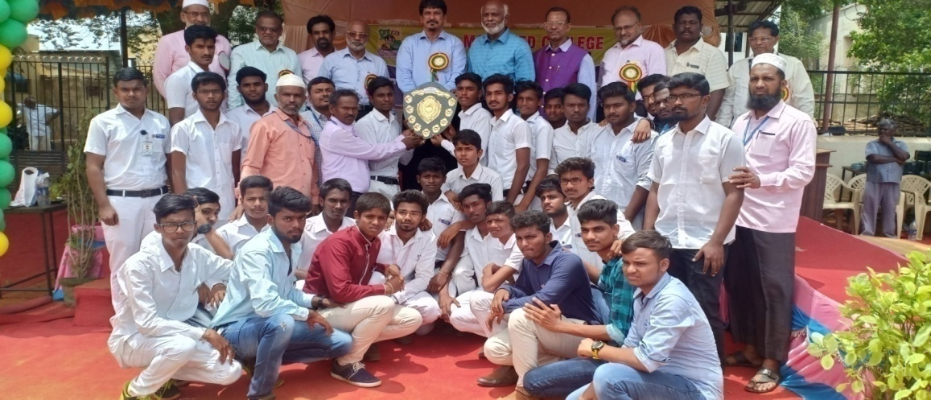
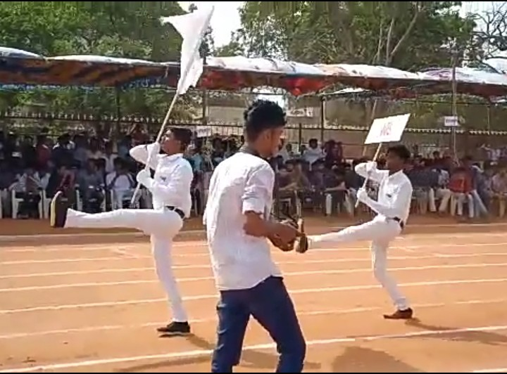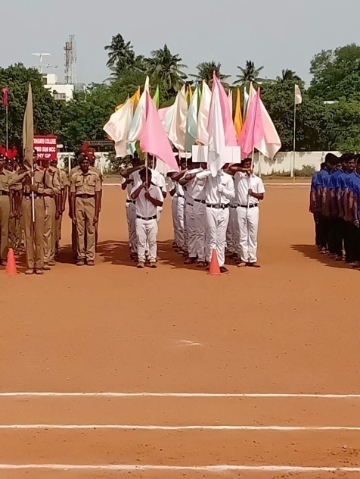
campus cleaning

On the date of 09/08/2018, CAMPUS CLEANING PROGRAMME was celebrated by the NSS VOLENTEER’S in JMC- Mosque.

The programme was a mass success because of the co-ordinator of volunteers.

NO. OF PARTICIPANT : 35 DATE :09/08/2018
VENUE : JMC-Mosque
HOURS :04.00 hrs TIME : 09:30 AM to 01:30 PM

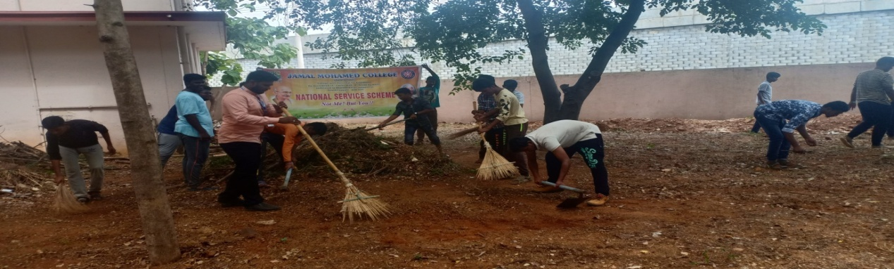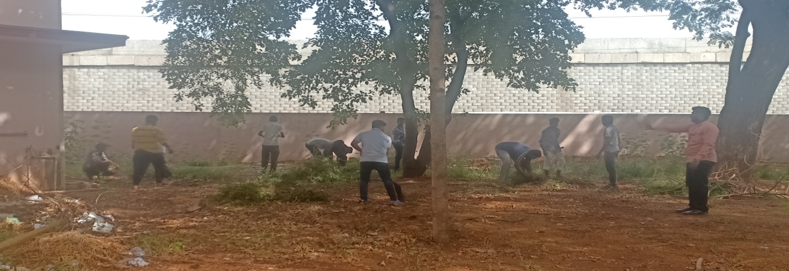

SWATCH BHARATH PROGRAMME

On the date of 09/08/2018, SWATCH BHARATH PROGRAMME was conducted by the NSS VOLENTEER’S in Palakkarai.

The programme was a mass success because of the co-ordinator of volunteers.

NO. OF PARTICIPANT : 60 DATE :09/08/2018
VENUE : Palakkarai
HOURS :03.30 hrs TIME : 10:00 AM to 01:30 PM

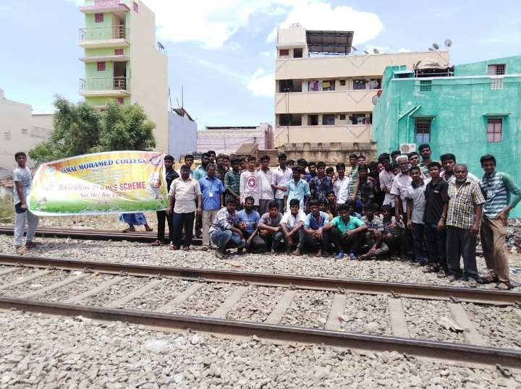
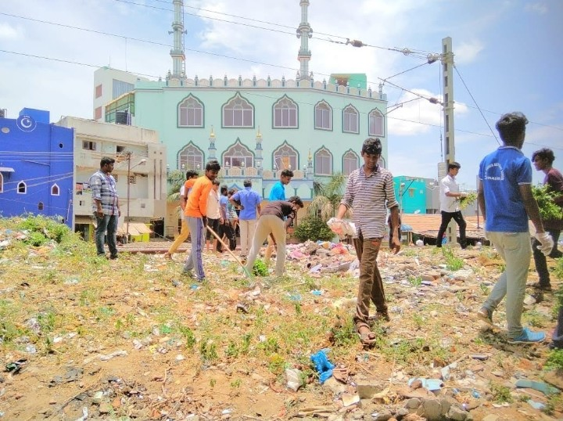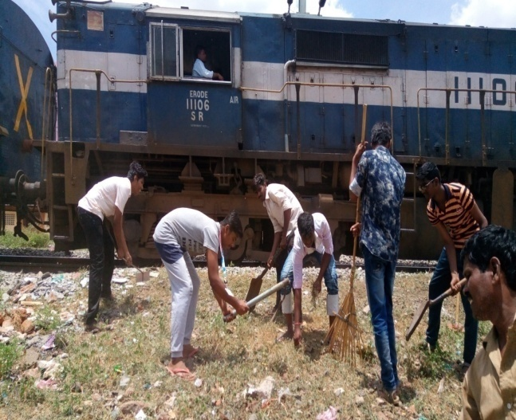

INDEPENDENCE DAY PROGRAMME

On the date of 15/08/2018, INDEPENDENCE DAY PROGRAMME was celebrated by the NSS VOLENTEER’S in Bharathidhasan University , Trichy.

The programme was a mass success because of the co-ordinator of volunteers.

NO. OF PARTICIPANT : 32 DATE :15/08/2018
VENUE : BHARATHIDHASAN UNIVERSITY
HOURS :06.00 hrs TIME : 09:30 AM to 03:30 PM
CHIEF GUEST : BDU VICE CHANCELLOR MANI SELVAN
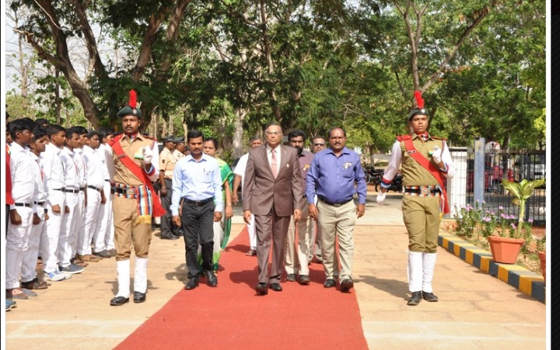
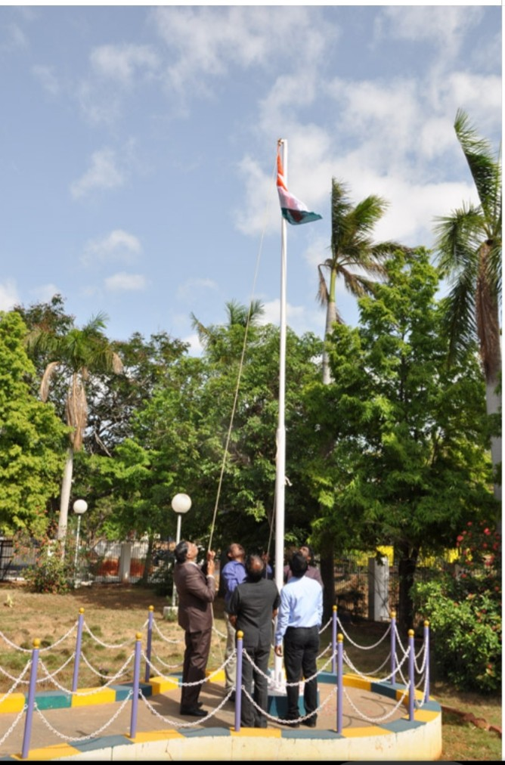

INDEPENDENCE DAY PROGRAMME

On the date of 15/08/2018, INDEPENDENCE DAY PROGRAMME was celebrated by the NSS VOLENTEER’S in JMC.

The programme was a mass success because of the co-ordinator of volunteers.
NO. OF PARTICIPANT : 25 DATE :15/08/2018
VENUE : JMC
HOURS :01.00 hrs TIME : 09:00 AM to 10:00 AM
CHIEF GUEST: THE SECRETARY,PRINCIPAL& TRESURER
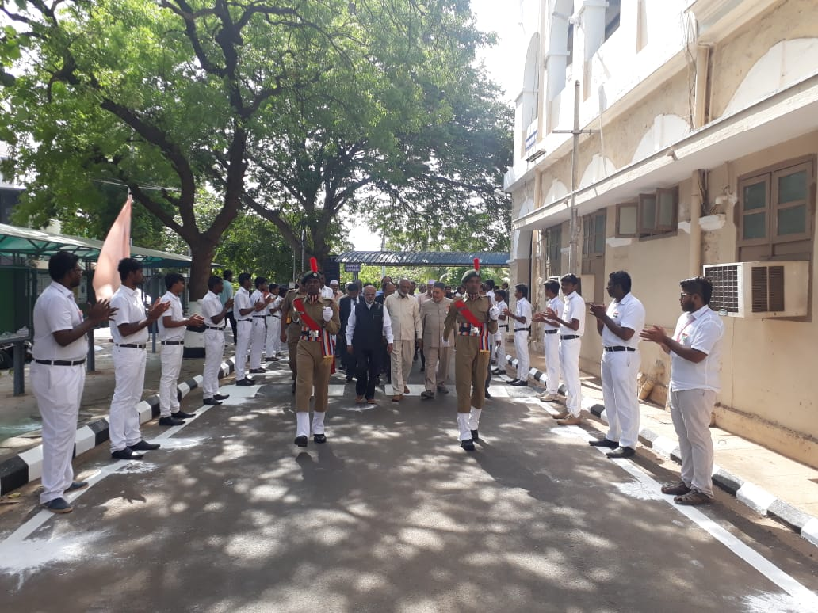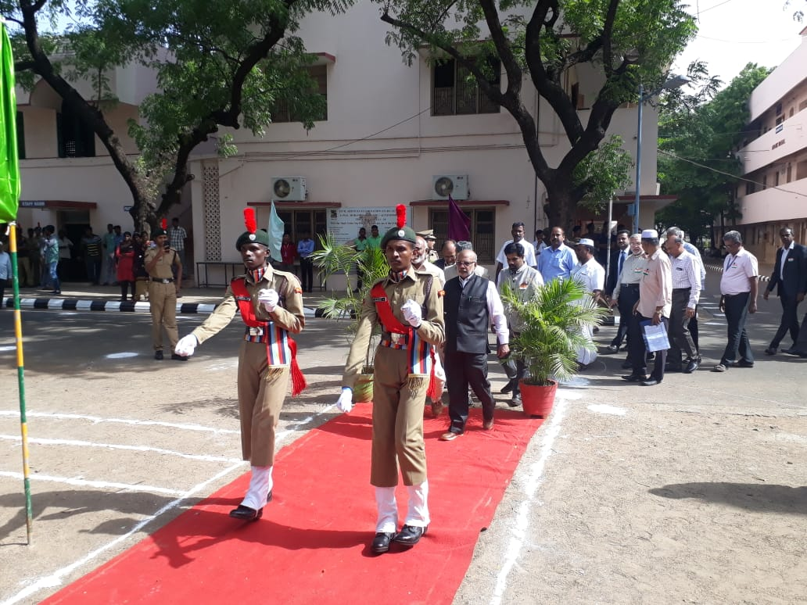

SCOLARSHIP PROGRAMME

On the date of 15/08/2018, SCOLARSHIP PROGRAMME was celebrated by the NSS VOLENTEER’S in JMC (A/C Auditorium).

The programme was a mass success because of the co-ordinator of volunteers.

NO. OF PARTICIPANT : 25 DATE :15/08/2018
VENUE : JMC (A/C auditorium
HOURS :04.00 hrs TIME : 10:00 AM to 02:00 PM
CHIEF GUEST: SRI LANKA MINISTER
C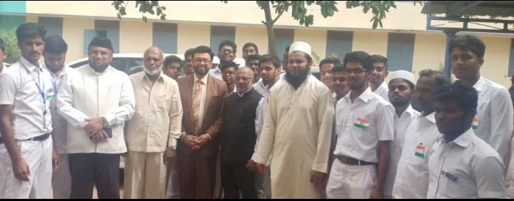

ADOPTING VILLAGE INDEPENDECE DAY
PROGRAMME CELEBRATION

On the date of 15/08/2018, ADOPTING VILLAGE INDEPENDENCE PROGRAMME CELEBRATION was celebrated by the NSS VOLENTEER’S in NAVALPATTU (BURMA COLONY).

The programme was a mass success because of the co-ordinator of volunteers.

NO. OF PARTICIPANT : 25 DATE :15/08/2018
VENUE : NAVALPATTU (BURMA COLONY)
HOURS :01.00 hrs TIME : 11:30 AM to 12:30 PM

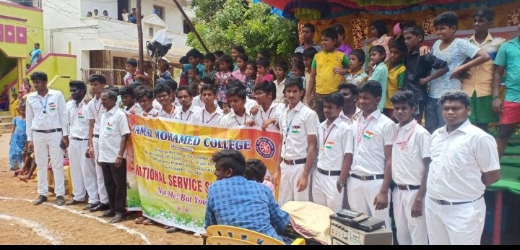

TABLET ISSUE

On the date of 28/08/2018, TABLET ISSUE was conducted by the NSS VOLENTEER’S in JMC.

The programme was a mass success because of the co-ordinator of volunteers.
NO. OF PARTICIPANT : 5 DATE :28/08/2018
VENUE : JMC
HOURS :03.00 hrs TIME : 08:30 AM to 11:30 AM
CHIEF GUEST: THE SECRETARY,PRINCIPAL& TRESURER

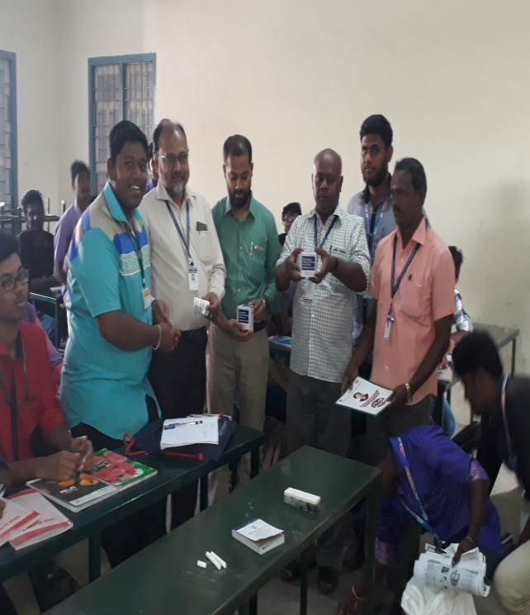

CAMPUS CLEANING

On the date of 01/09/2018, CAMPUS CLEANING was conducted by the NSS VOLENTEER’S in JMC campus.

The programme was a mass success because of the co-ordinator of volunteers.

NO. OF PARTICIPANT : 100 DATE :01/09/2018
VENUE : JMC campus
HOURS :03.30 hrs TIME : 08:30 AM to 12:00 PM

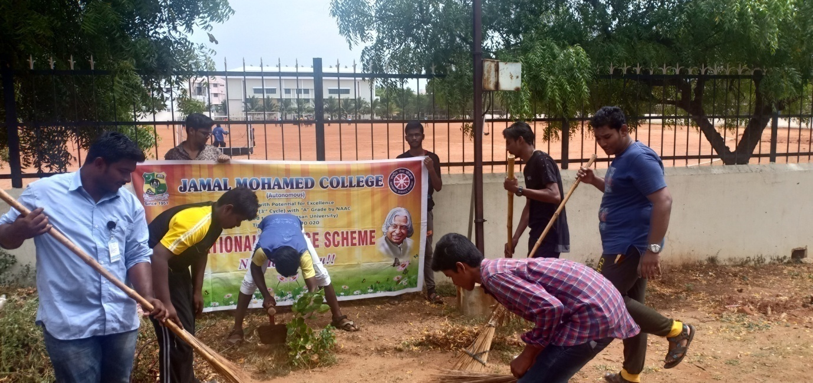
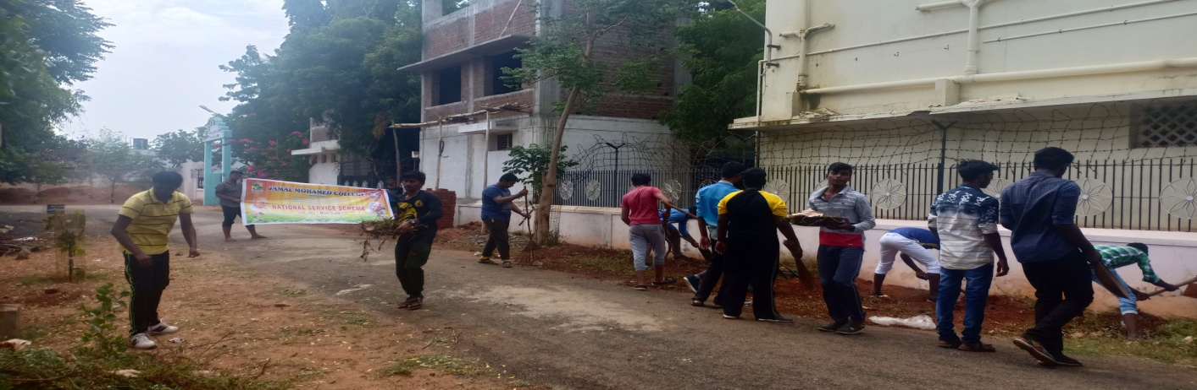

TEACHER’S DAY PROGRAMME

On the date of 05/09/2018, TEACHER’S DAY PROGRAMME was conducted by the NSS VOLENTEER’S in JMC campus.

The programme was a mass success because of the co-ordinator of volunteers.

NO. OF PARTICIPANT : 40 DATE :05/09/2018
VENUE : JMC campus
HOURS :01.30 hrs TIME : 07:30 AM to 08:45 AM

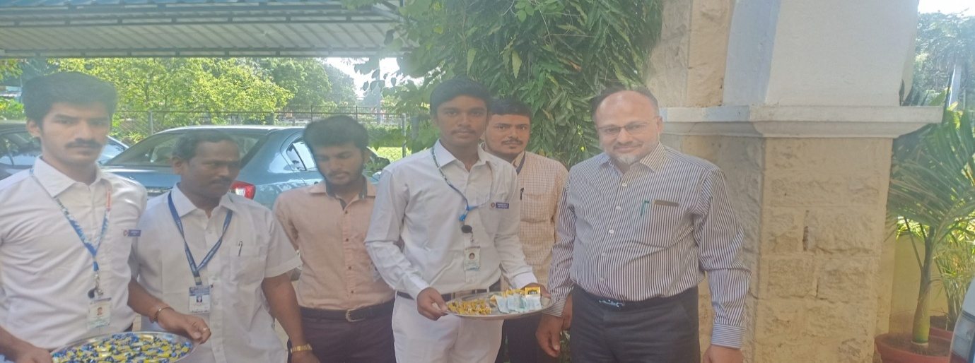
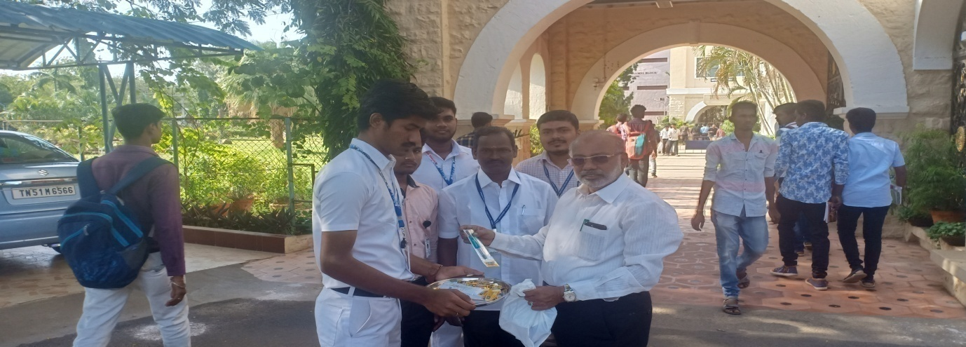

EYE CAMP

On the date of 05/09/2018, EYE CAMP was conducted by the NSS VOLENTEER’S in JOSHEP EYE HOSPITAL.

The programme was a mass success because of the co-ordinator of volunteers.

NO. OF PARTICIPANT : 20 DATE :05/09/2018
VENUE : JOSHEP EYE HOSPITAL
HOURS :02.00 hrs TIME : 10:00 AM to 12:00 PM
CHIEF GUEST : DEPUTY COMMISNOR OF POLICE Mr.A.MAYILVAGANAN
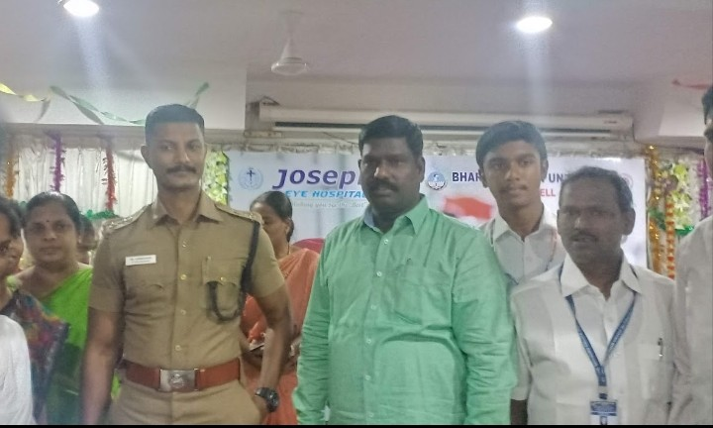

LITRACY DAY

On the date 08/09/2018, LITRACY DAY was conducted by the NSS VOLENTEER’S in KHAJANAGAR.

The programme was a mass success because of the co-ordinator of volunteers.

NO. OF PARTICIPANT : 20 DATE :08/09/2018
VENUE : Khajanagar
HOURS :01.30 hrs TIME : 03:00 PM to 04:30 PM
CHIEF GUEST : TRESURER,VICE PRINCIPAL
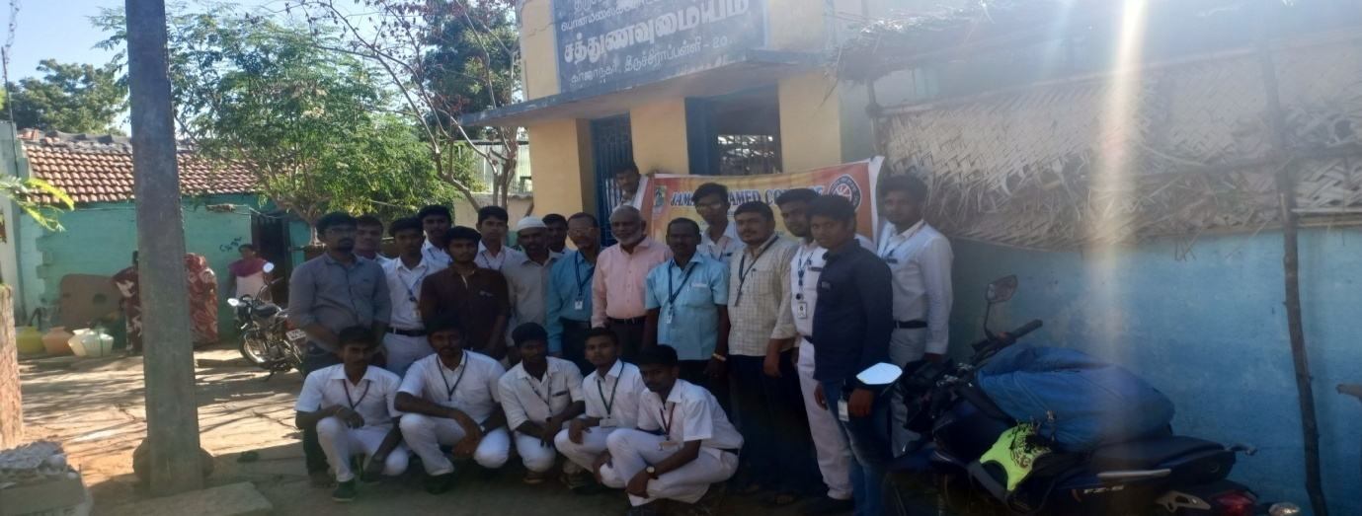
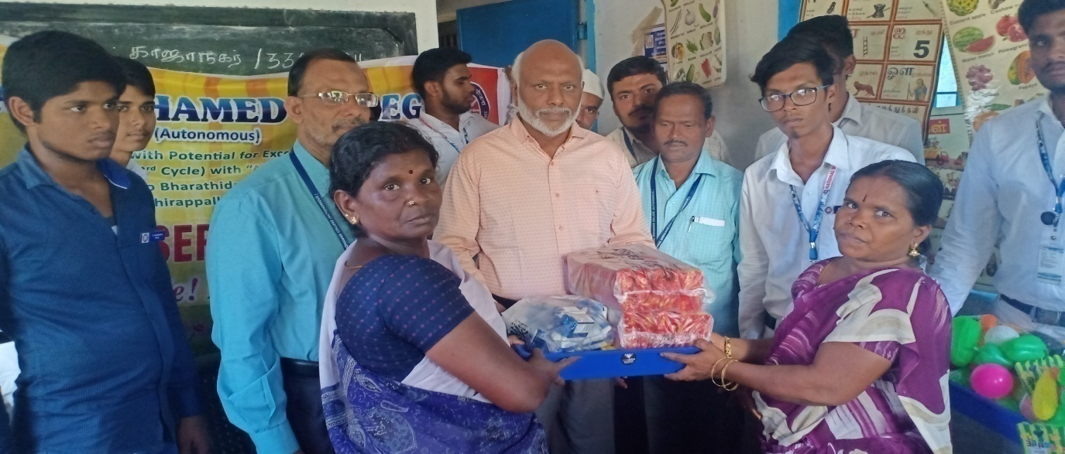

ORIENTATION PROGRAMME

On the date of 10/09/2018, ORIENTATION PROGRAMME was conducted by the NSS VOLENTEER’S in HUSSAINUDEEN HALL.

The programme was a mass success because of the co-ordinator of volunteers.

NO. OF PARTICIPANT : 110 DATE :10/09/2018
VENUE : Hussainudeen hall
HOURS :02.00 hrs TIME : 11:30 AM to 01:30 PM
CHIEF GUEST : SUBRAMAIYAM
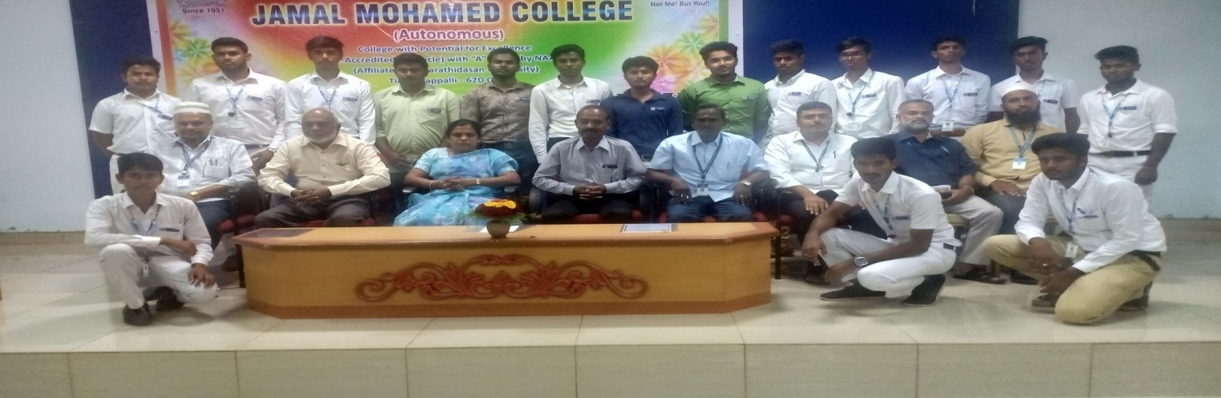
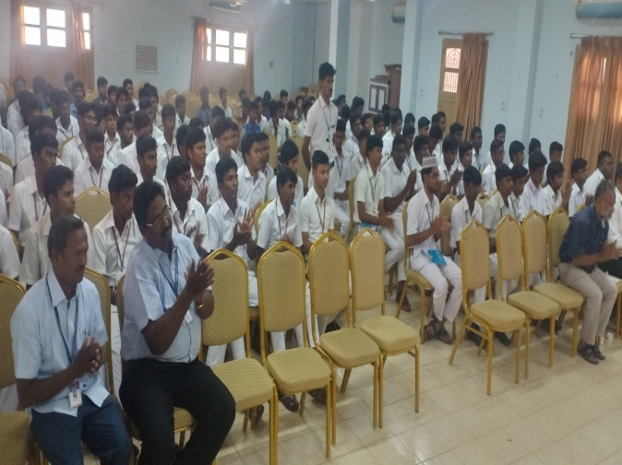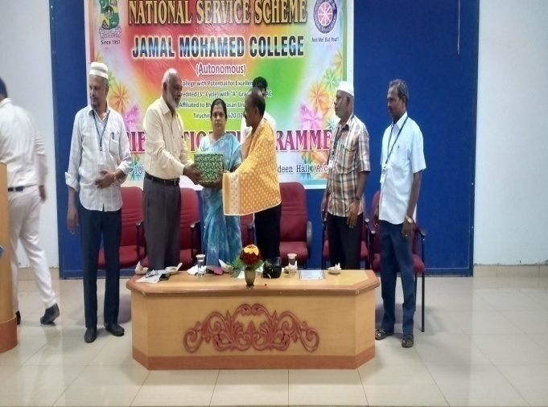

PERIYAR BIRTHDAY

On the date of 17/09/2018, PERIYAR BIRTHDAY was conducted by the NSS VOLENTEER’S in BDU.

The programme was a mass success because of the co-ordinator of volunteers.

NO. OF PARTICIPANT : 36 DATE :17/09/2018
VENUE : BDU
HOURS :04.00 hrs TIME : 10:00 AM to 02:00 PM
CHIEF GUEST ; BDU VICE CHANCELLOR MANI SELVAN
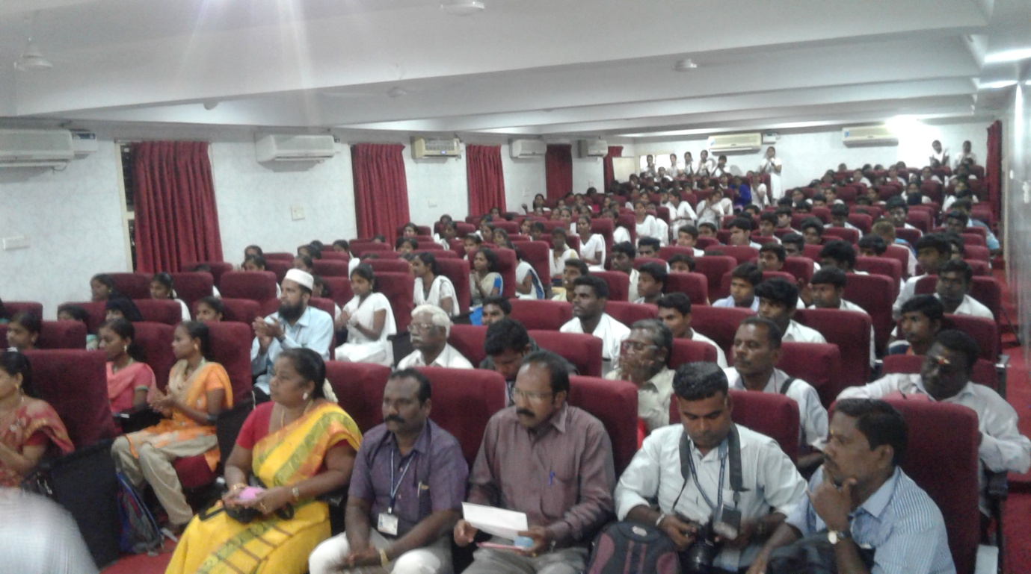

INTERVIEW PROGRAMME

On the date of 19/09/2018, INTERVIEW PROGRAMME was conducted by the NSS VOLENTEER’S in JMC.

The programme was a mass success because of the co-ordinator of volunteers.

NO. OF PARTICIPANT : 10 DATE :19/09/2018
VENUE : JMC
HOURS :05.00 hrs TIME : 08:30 AM to 01:30 PM
CHIEF GUEST : MP. P. KUMAR, MP. T. RATHINAVEL, MINISTER TOUSIERM & DEVELOPE MENT VELL MANDI NATRAJAN, BACK WARD CLASS MINISTER VALARMATHY
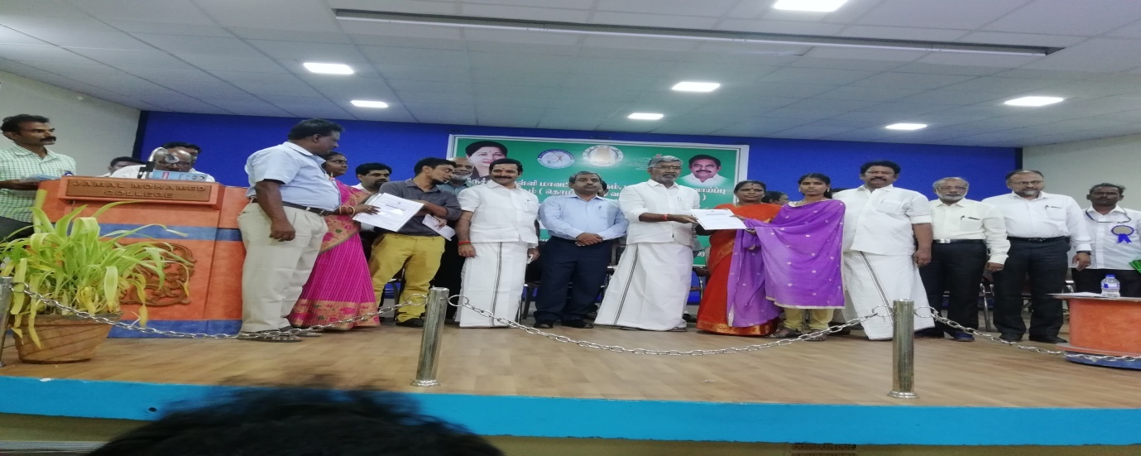
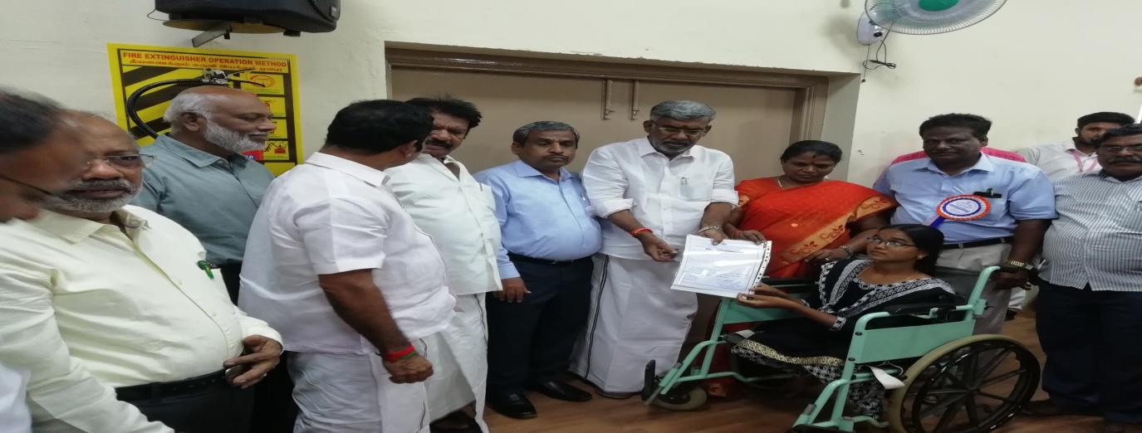
PRE-RD SELECTION

On the date of 20/09/2018, PRE-RD SELECTION was conducted by the NSS VOLENTEER’S in BDU.

The programme was a mass success because of the co-ordinator of volunteers.

NO. OF PARTICIPANT : 40 DATE :20/09/2018
VENUE : BDU
HOURS :10.00 hrs TIME : 08:30 AM to 06:00 PM CHIEF GUEST: REGINAL DIRECTOR SAMUVEL SELLIAH
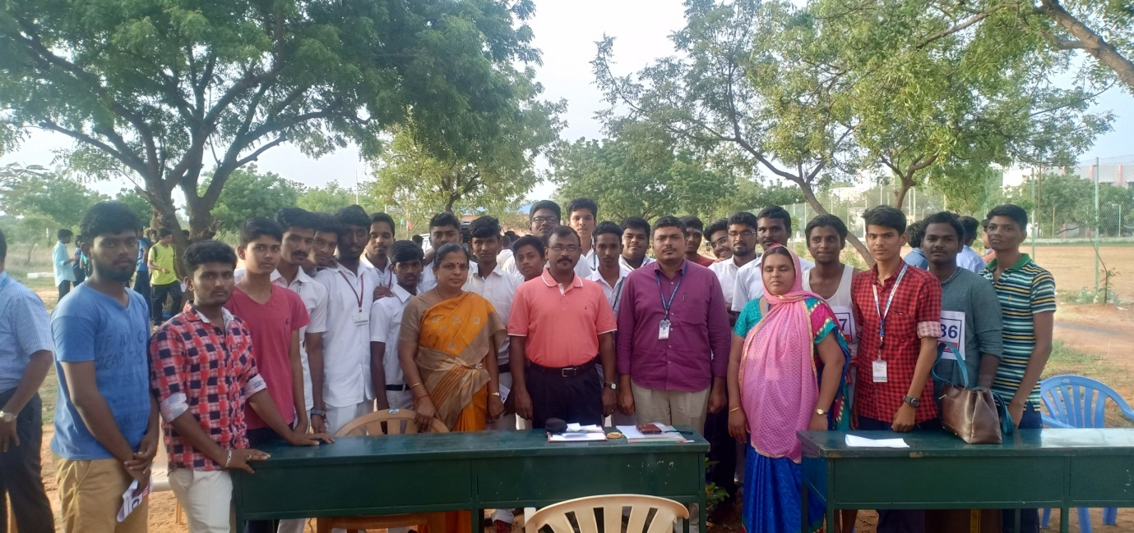

NSS DAY PROGRAMME

On the date of 24/09/2018, NSS DAY PROGRAMME was conducted by the NSS VOLENTEER’S in KHAJAMIAN AUDITORIUM.

The programme was a mass success because of the co-ordinator of volunteers.

NO. OF PARTICIPANT : 100 DATE :24/09/2018
VENUE : Khajamian auditorium
HOURS :05.00 hrs TIME : 08:30 AM to 01:30 PM
CHIEF GUEST : ALLI RANI BALAJI
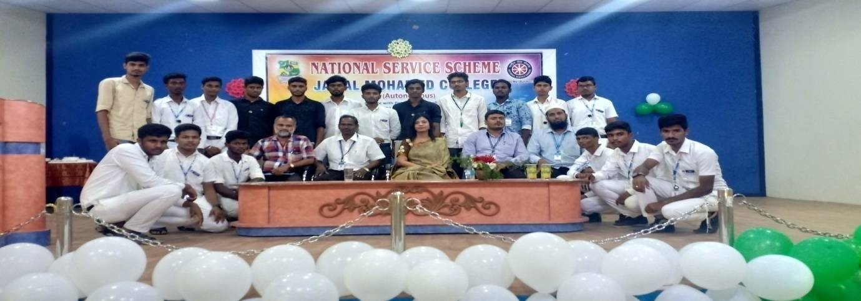
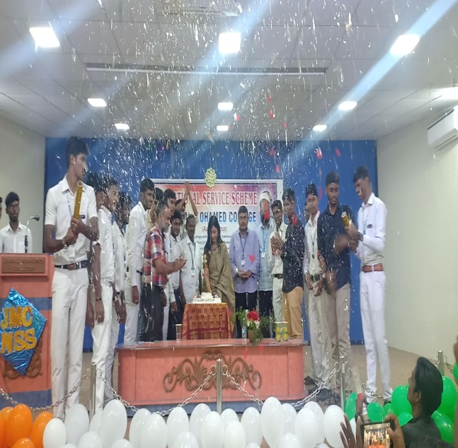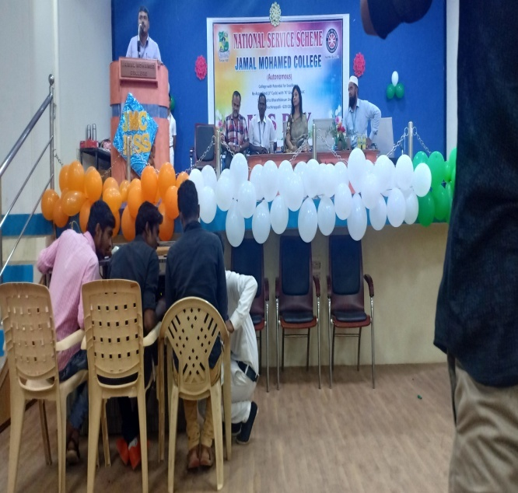

NSS DAY PROGRAMME

On the date of 24/09/2018, NSS DAY PROGRAMME was conducted by the NSS VOLENTEER’S in BDU.

The programme was a mass success because of the co-ordinator of volunteers.

NO. OF PARTICIPANT : 10 DATE :24/09/2018
VENUE : BDU
HOURS :07.00 hrs TIME : 10:00 AM to 5:00 PM
CHIEF GUEST ; BDU VICE CHANCELLOR MANI SELVAN

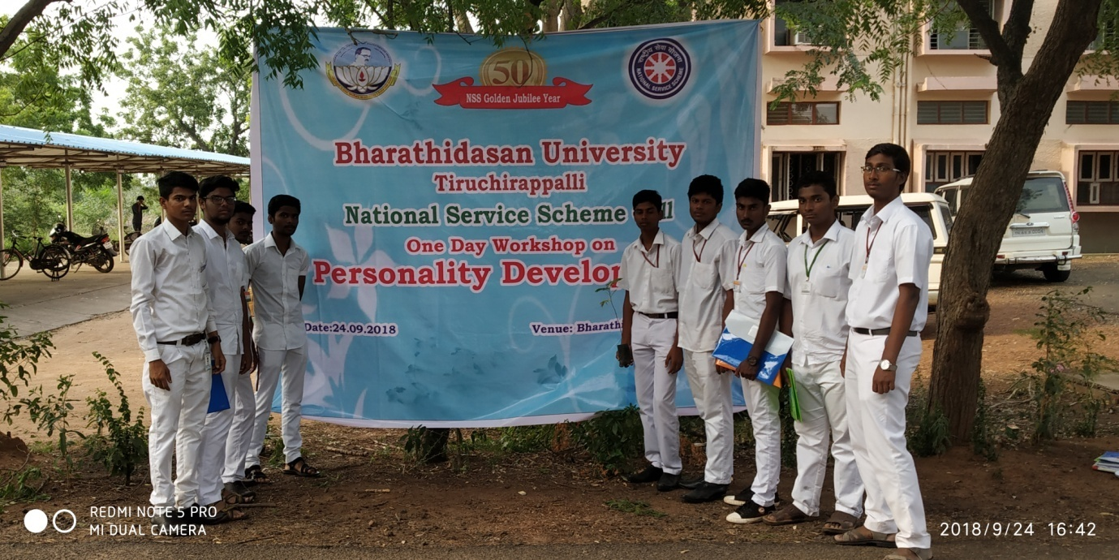

MARATHON PROGRAMME

On the date of 23/09/2018, MARATHON PROGRAMME was conducted by the NSS VOLENTEER’S in ULAVAR SANTHAI.

The programme was a mass success because of the co-ordinator of volunteers.

NO. OF PARTICIPANT : 30 DATE :23/09/2018
VENUE : Ulavar santhai
HOURS :01.30 hrs TIME : 06:00 AM to07:30 AM
CHIEF GUEST : THE DIST. COLLECTOR TRICHY & MINISTER
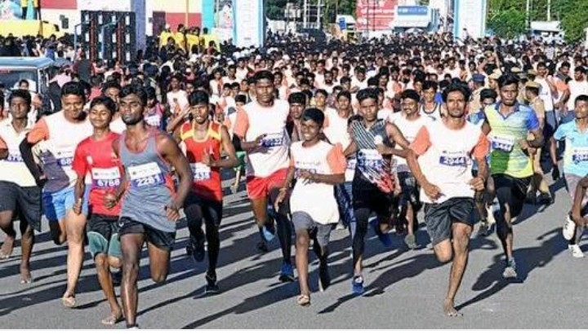

BDU FEST

On the date of 28,29,30/09/2018, BDU FEST – 2018 was conducted by the NSS VOLENTEER’S in BDU.

The programme was a mass success because of the co-ordinator of volunteers.

NO. OF PARTICIPANT : 90 DATE :28/09/2018 – 30/09/2018
VENUE : BDU
HOURS :15.00 hrs TIME : 07:00 AM to 10:00 PM
CHIEF GUEST: ALAGAPPA UNVERSITY VC DR.SUBBAIYAH
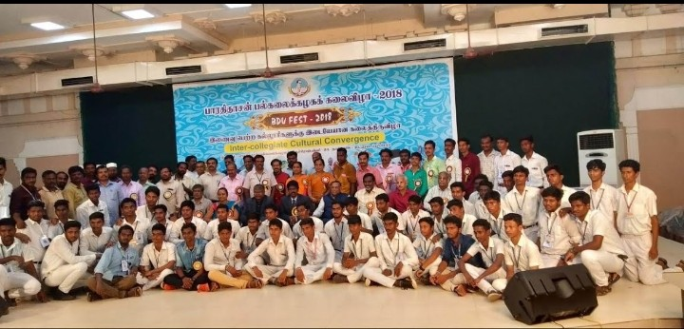

SWATCH SURVICSHAN

On the date of 02/10/2018, SWATCH SURVICSHAN was conducted by the NSS VOLENTEER’S in ANNA STADIUM.

The programme was a mass success because of the co-ordinator of volunteers.

NO. OF PARTICIPANT : 30 DATE :02/10/2018
VENUE : ANNA STADIUM
HOURS :02.00 hrs TIME : 07:00 AM to 09:00 AM
CHIEF GUEST: GOBINATH,AATHI, DC MAYILVAGAN
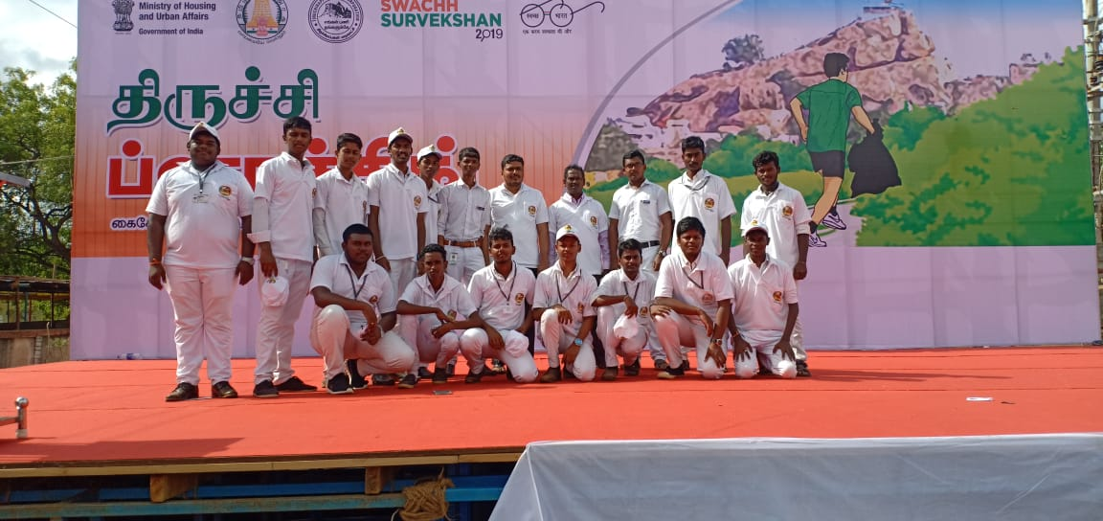
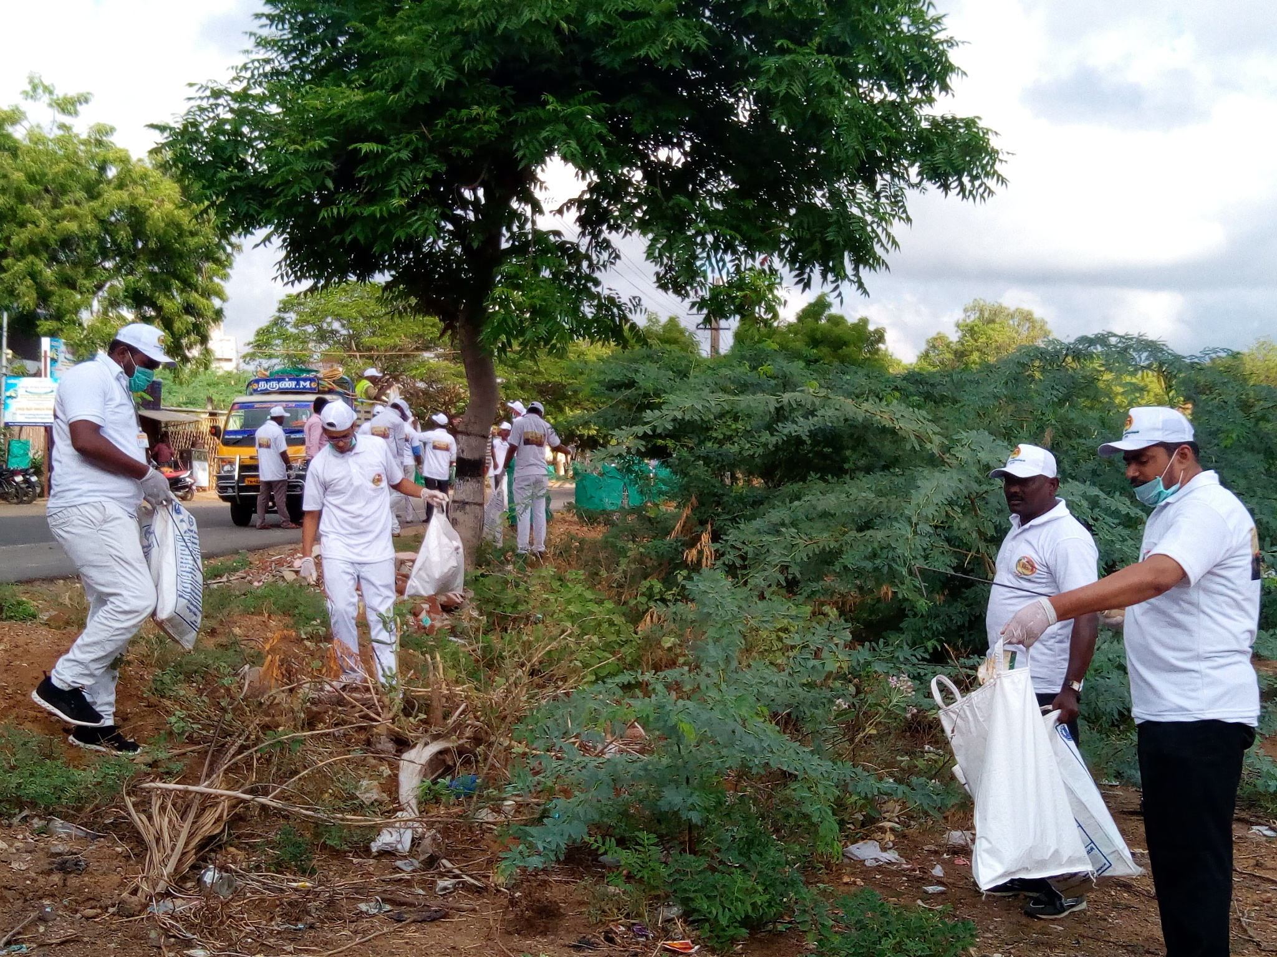

LEADERSHIP PROGRAMME

On the date of 06/10/2018, LEADESHIP PROGRAMME was conducted by the NSS VOLENTEER’S in ANNA STADIUM.

The programme was a mass success because of the co-ordinator of volunteers.

NO. OF PARTICIPANT : 120 DATE :06/10/2018
VENUE : Management seminar hall
HOURS :02.00 hrs TIME:01:30PMto03:30PM
CHIEF GUEST: TRICHY DIST.JUDGE
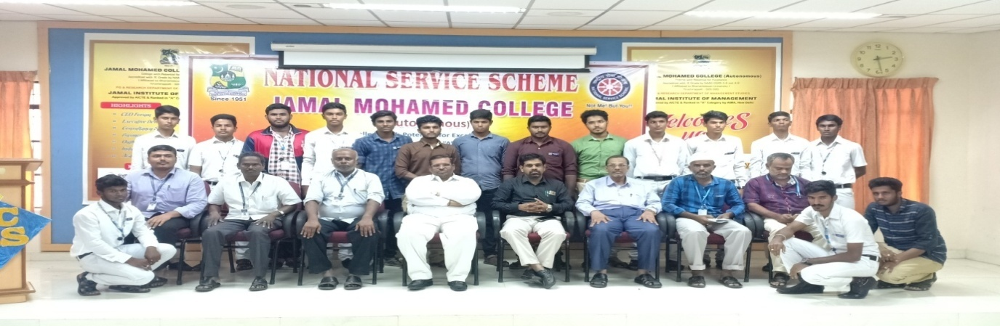

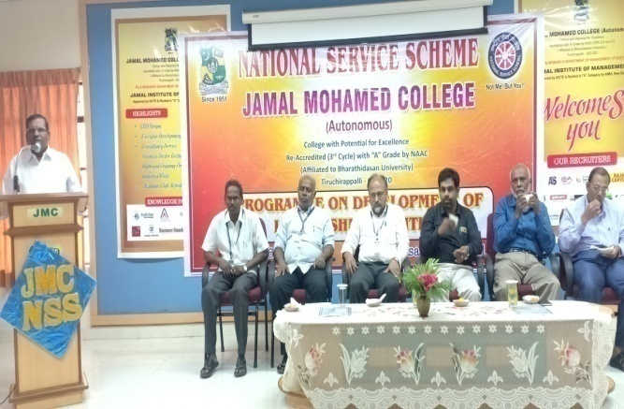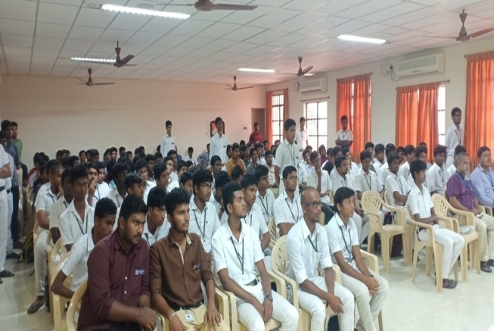
CLEANING PROGRAMME

On the date of 10/10/2018, CLEANING PROGRAMME was conducted by the NSS VOLENTEER’S in INAMKULATHUR.

The programme was a mass success because of the co-ordinator of volunteers.

NO. OF PARTICIPANT : 60 DATE :10/10/2018
VENUE :Inamkulathur
HOURS :08.00 hrs TIME : 08:30 AM to 04:00 PM

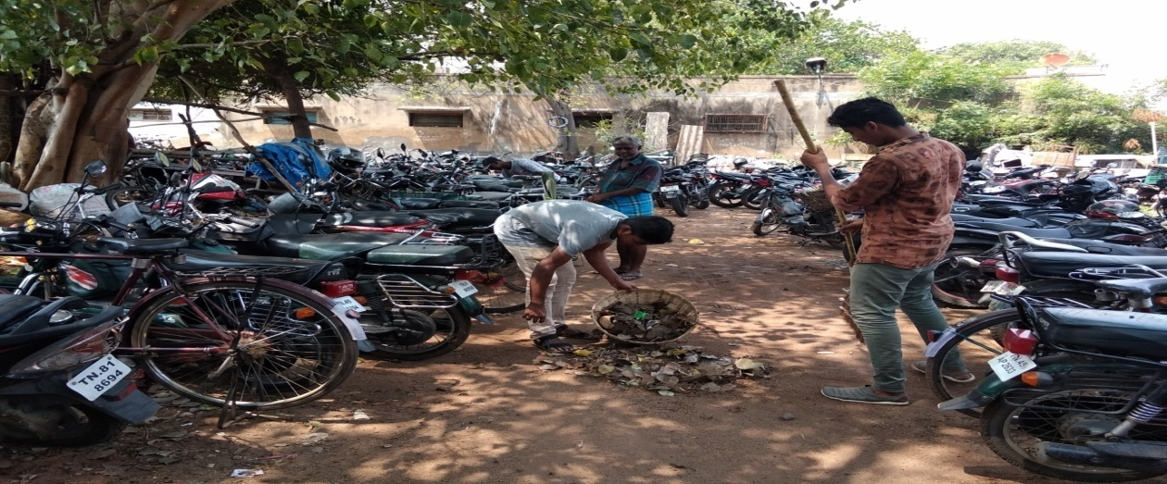

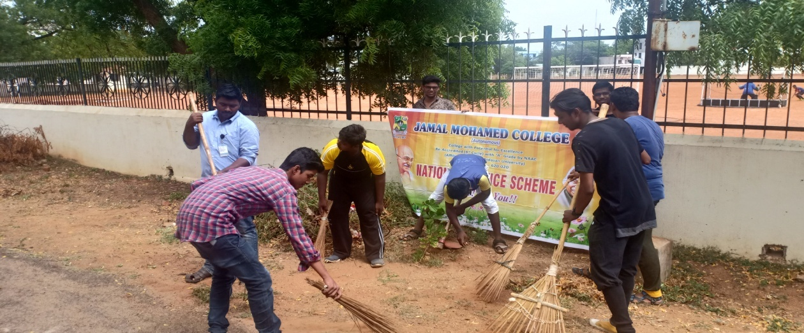

FIRE AWARNESS PROGRAMME

On the date of 11/10/2018, FIRE AWARNESS PROGRAMME was conducted by the NSS VOLENTEER’S in JMC.

The programme was a mass success because of the co-ordinator of volunteers.

NO. OF PARTICIPANT : 60 DATE :11/10/2018
VENUE : JMC
HOURS :02.00 hrs TIME : 11:30 AM to 01:30 PM

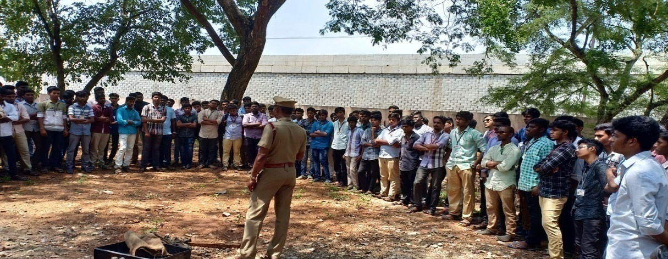
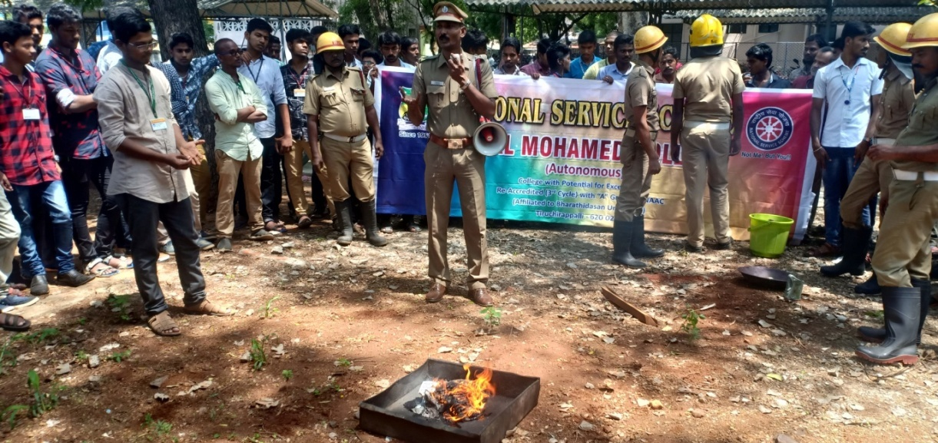

ANNAI ASHRAM PROGRAMME

On the date of 11/10/2018, ANNAI ASHRAM PROGRAMME was conducted by the NSS VOLENTEER’S in AIRPORT.

The programme was a mass success because of the co-ordinator of volunteers.

NO. OF PARTICIPANT : 20 DATE :11/10/2018
VENUE : AIRPORT
HOURS :02.00 hrs TIME : 01:30 PM to 03:30 PM

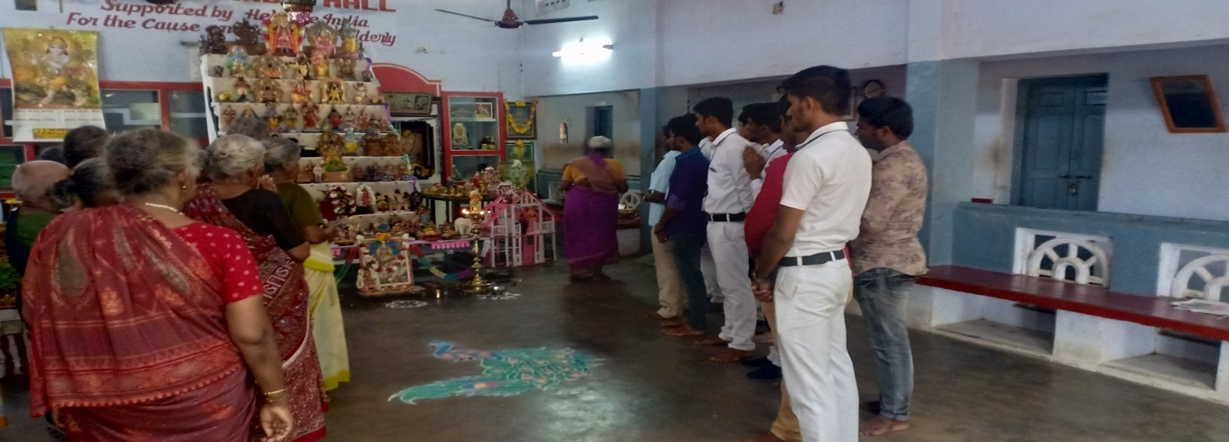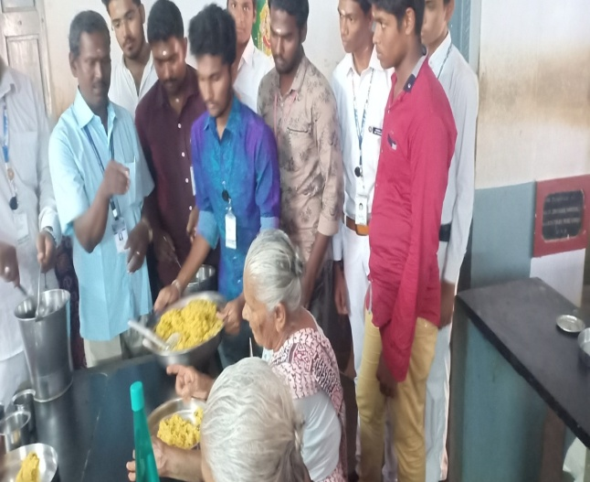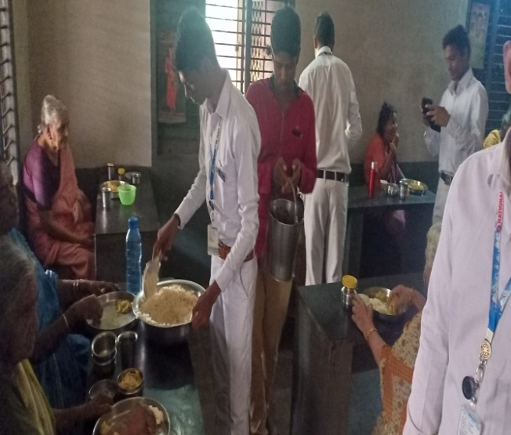

CLEANING PROGRAMME

On the date of 13/10/2018, CLEANING PROGRAMME was conducted by the NSS VOLENTEER’S in GandhiI market

The programme was a mass success because of the co-ordinator of volunteers.
NO. OF PARTICIPANT : 100 DATE :13/10/2018
VENUE : GandhiI market
HOURS: 5 hrs TIME : 08:30 AM to 1:30 PM
CHIEF GUEST: COPORATION COMISNIOR RAVI CHANDRAN
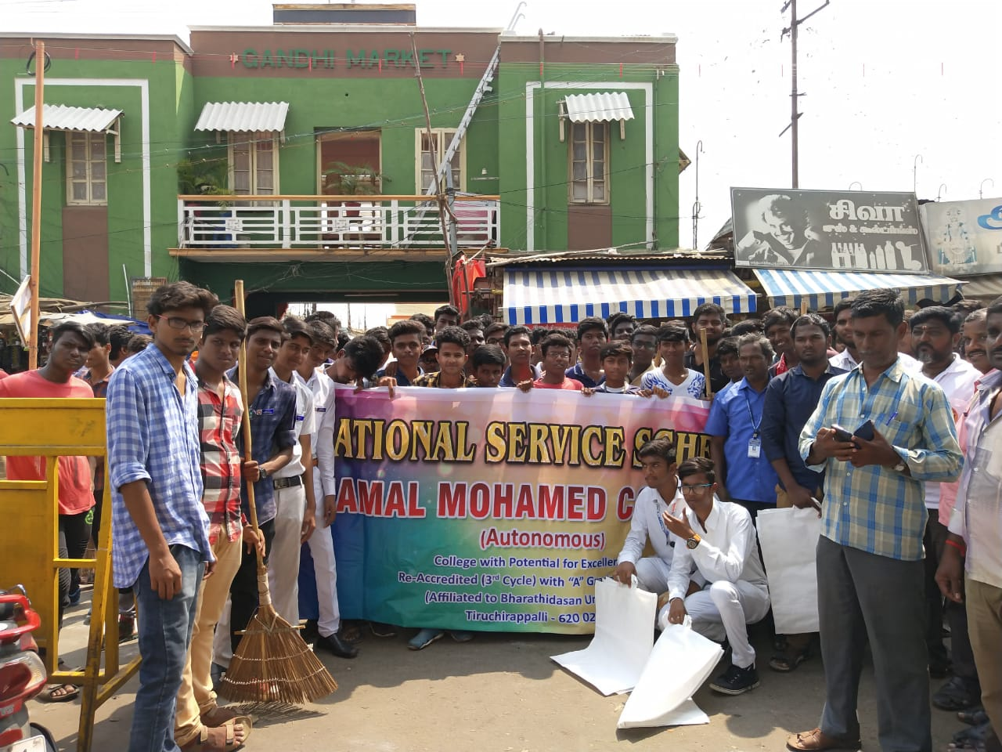
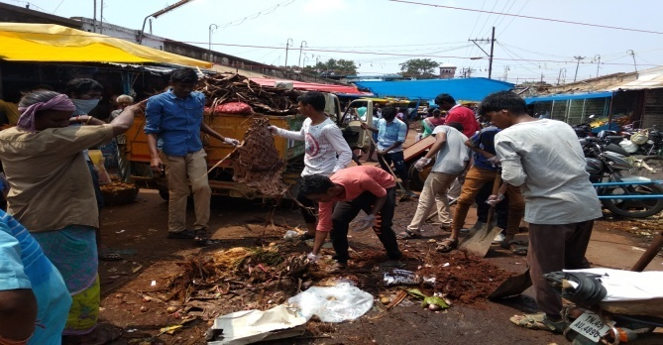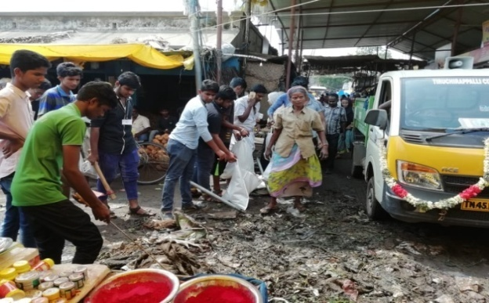
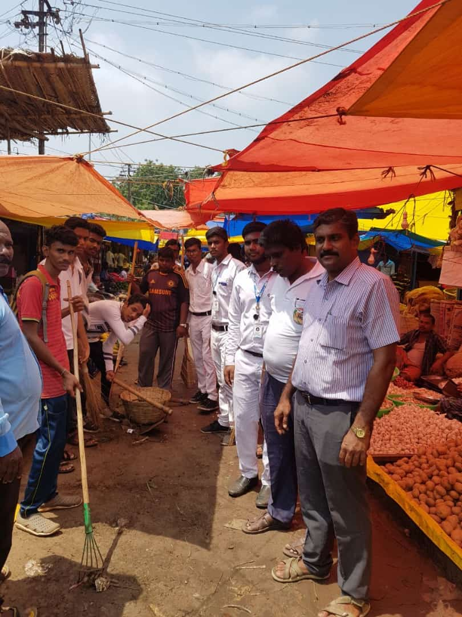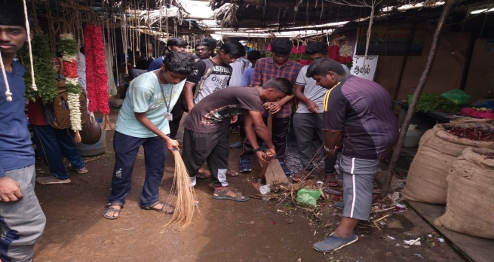

BLOOD CAMP

On the date of 13/10/2018, Blood camp was conducted by the NSS VOLENTEER’S in subramaiyapuram

The programme was a mass success because of the co-ordinator of volunteers.
NO. OF PARTICIPANT : 60 DATE :13/10/2018
VENUE : Subramaiyapuram
HOURS: 5 hrs TIME : 08:30 AM to 1:30 PM
CHIEF GUEST: MEENA
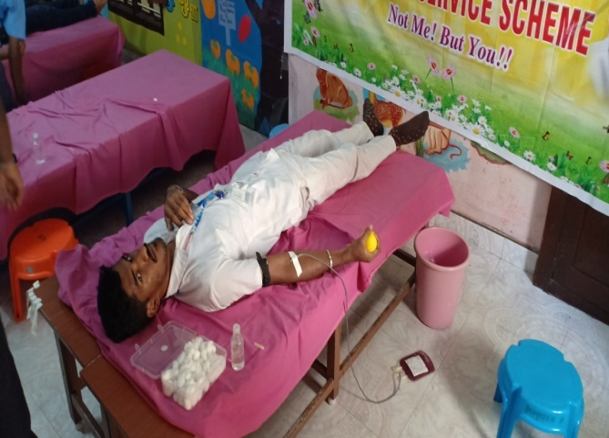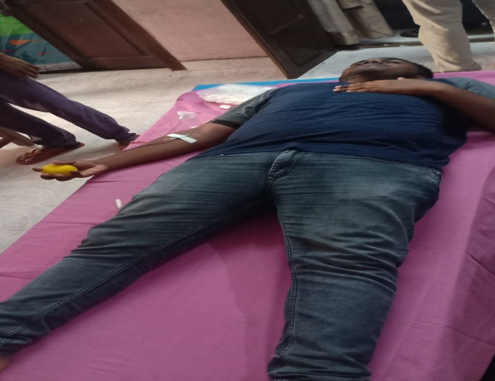
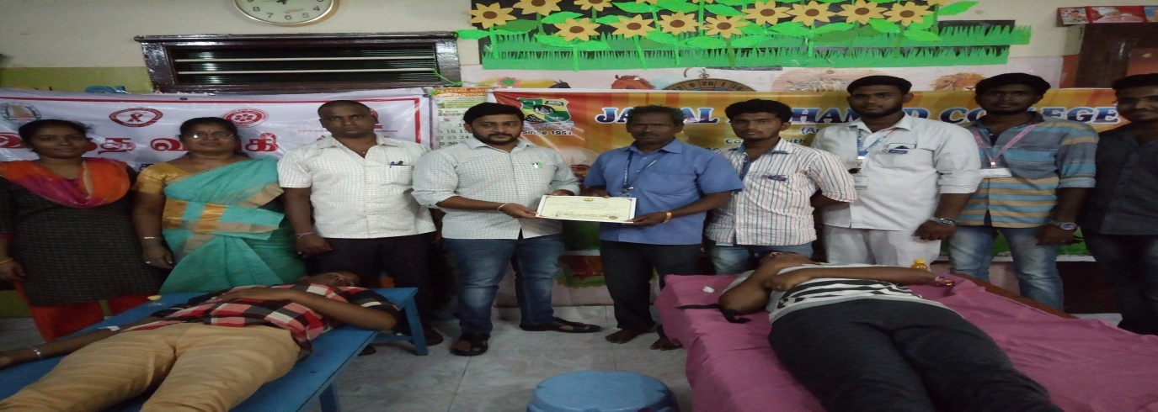

NATIONAL YOUTH DAY

On the date of 15/10/2018,national youth day was conducted by the NSS VOLENTEER’S in JMC
The programme was a mass success because of the co-ordinator of volunteers.
NO. OF PARTICIPANT : 100 DATE :15/10/2018
VENUE : KHAJAMIAN Auditorium
HOUR; 5 hrs TIME : 08:30 AM to 1:30 PM
CHIEF GUEST: SURENDHAR PONNALAGAR SCIENTIST
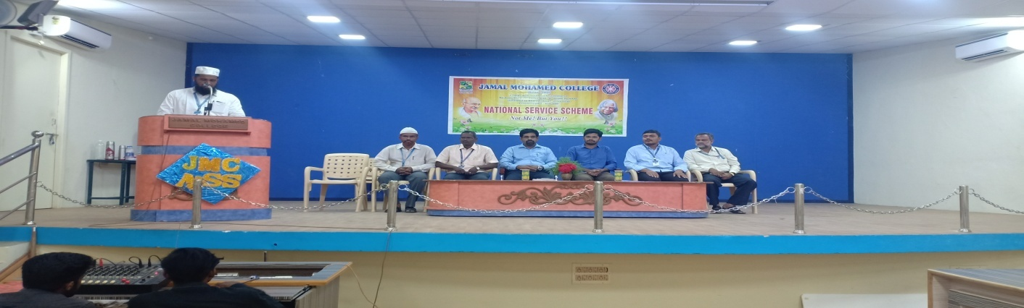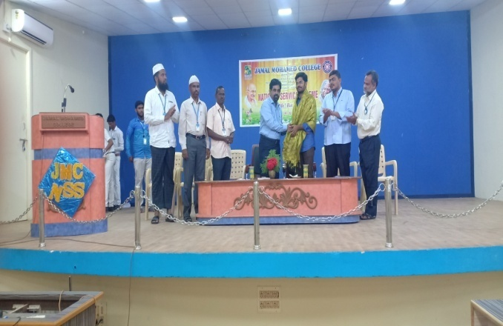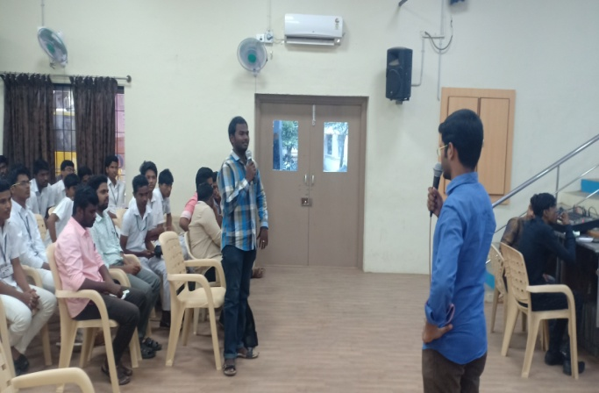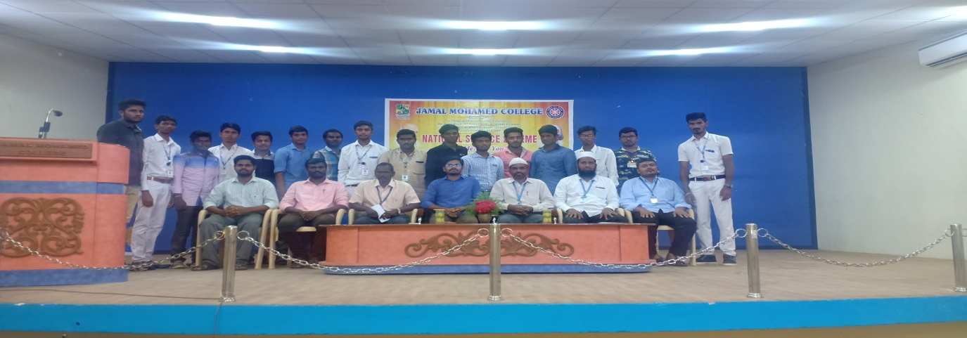

SEMINAR ABOUT NATURALS

On the date of 28/10/2018,SEMINAR about naturals was conducted by the NSS VOLENTEER’S in Thoranangurichi.
The programme was a mass success because of the co-ordinator of volunteers.
NO. OF PARTICIPANT: 20 DATE : 28/10/2018
VENUE: Thoranangurichi
HOUR; 9 hrs TIME : 9:00 AM to 6:00 PM
CHIEF GUEST: TRICHY DCP
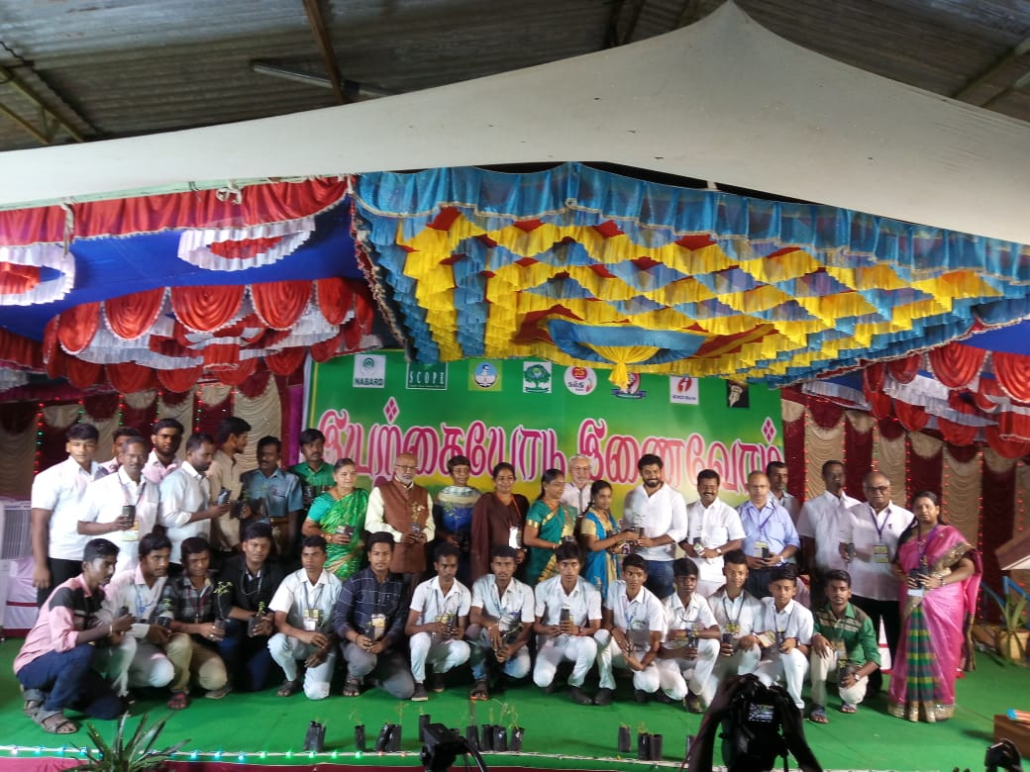

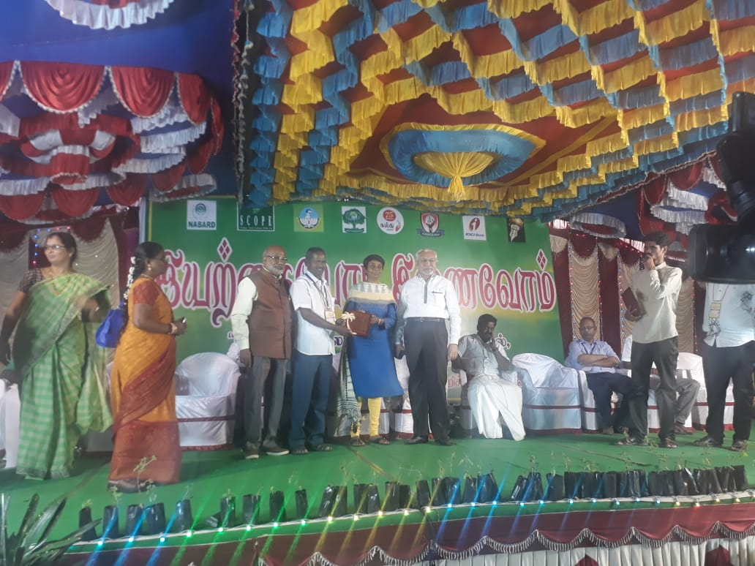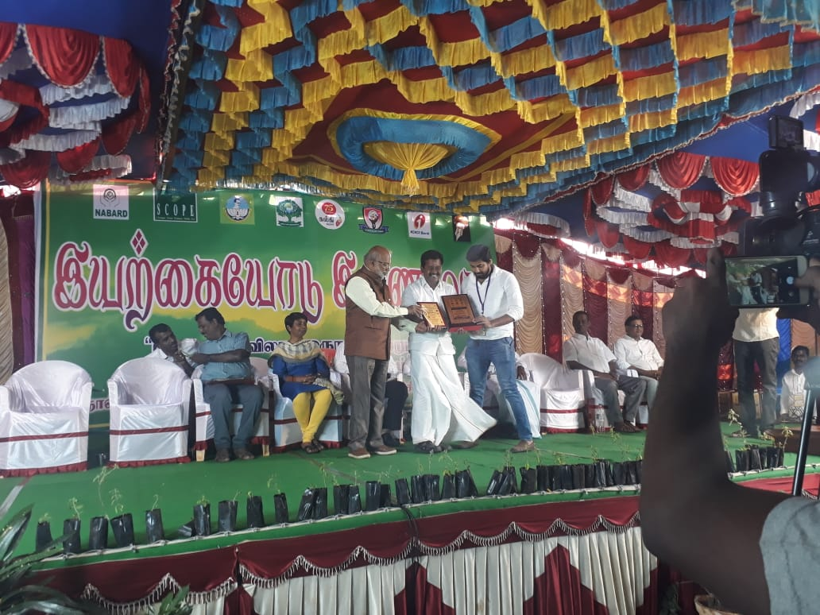

SARTHAR VALLABHAI PATEL PLEDGE

On the date of 29/10/2018, SARTHAR VALLABHAI PATEL PLEDGE was conducted by the NSS VOLENTEER’S in JMC
The programme was a mass success because of the co-ordinator of volunteers.
NO. OF PARTICIPANT: 50 DATE : 29/10/2018
VENUE: JMC
HOUR; 1hr TIME : 1:30PM TO 2:30PM
CHIEF GUEST: THE SECTARY, PRINCIPAL & TREASURER
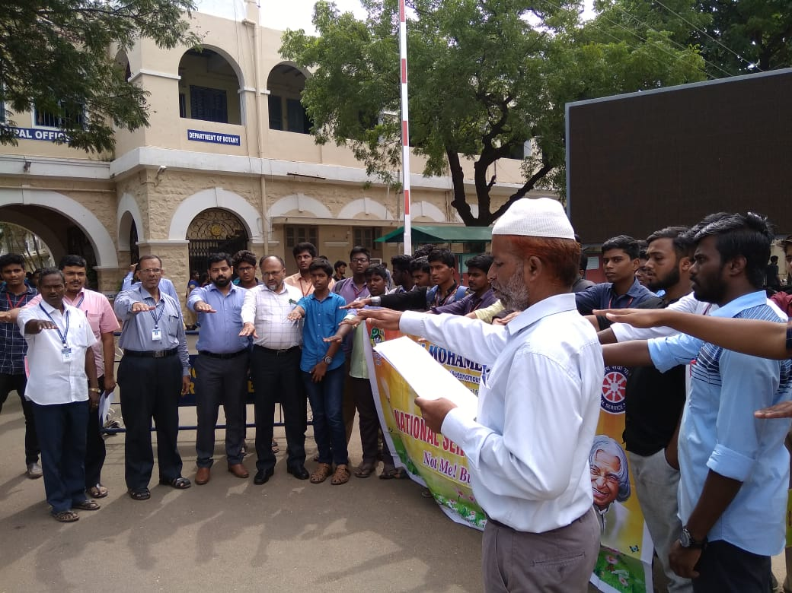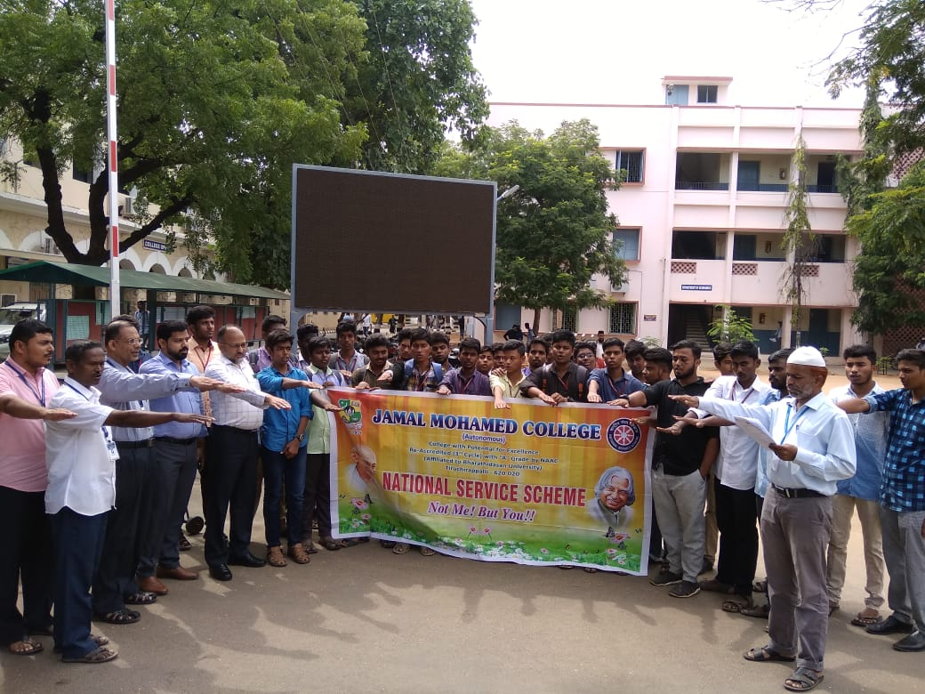

GAJA RELEIF FUND

On the date of 23/11/2018, GAJA RELEIF FUND was conducted by the NSS VOLENTEER’S in Vetharanyam
The programme was a mass success because of the co-ordinator of volunteers.
NO. OF PARTICIPANT : 50 DATE : 23/11/2018
VENUE : Vetharanyam
HOUR; 13hrs TIME : 9.00AM TO 10.00PM

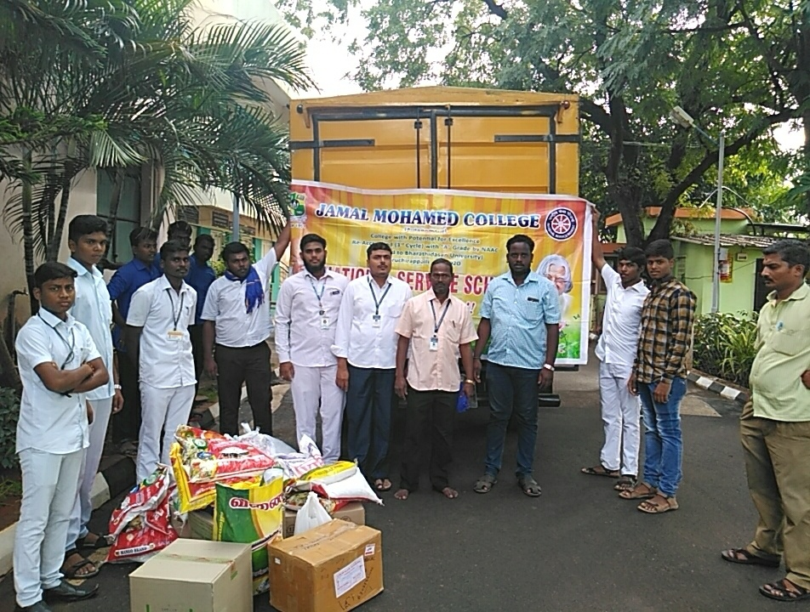

SWATCH BARATH PROGRAMME

On the date of 03/12/2018,SWATCH BARATH PROGRAMME was conducted by the NSS VOLENTEER’S in Municipality office
The programme was a mass success because of the co-ordinator of volunteers.
NO. OF PARTICIPANT :30 DATE : 03/12/2018
VENUE: Municipality office
HOUR; 2 hrs TIME: 11.30AM TO 1.30PM

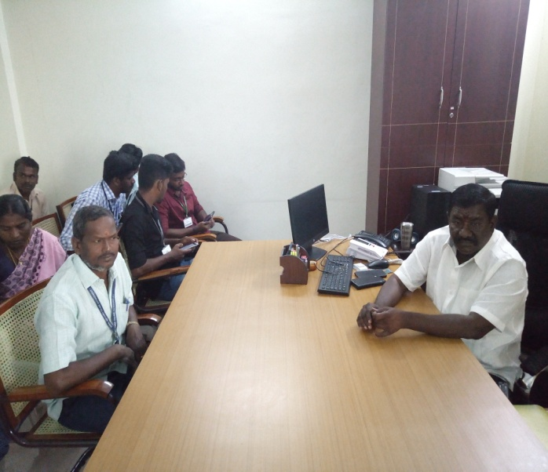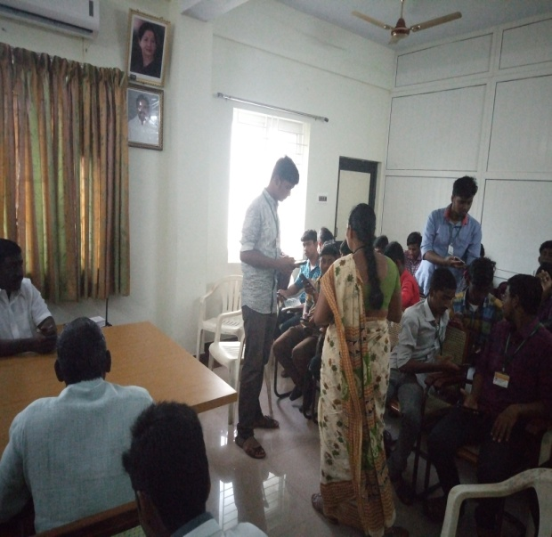

BDU CLEANING PROGRAMME

On the date of 13/12/2018 & 14/12/18, BDU CLEANING PROGRAMME was conducted by the NSS VOLENTEER’S in BDU
The programme was a mass success because of the co-ordinator of volunteers.
NO. OF PARTICIPANT :150 DATE : 13/12/2018 & 14/12/18
VENUE: BDU
HOUR; 8 & 8 hrs TIME: 9.00AM TO 5.00PM

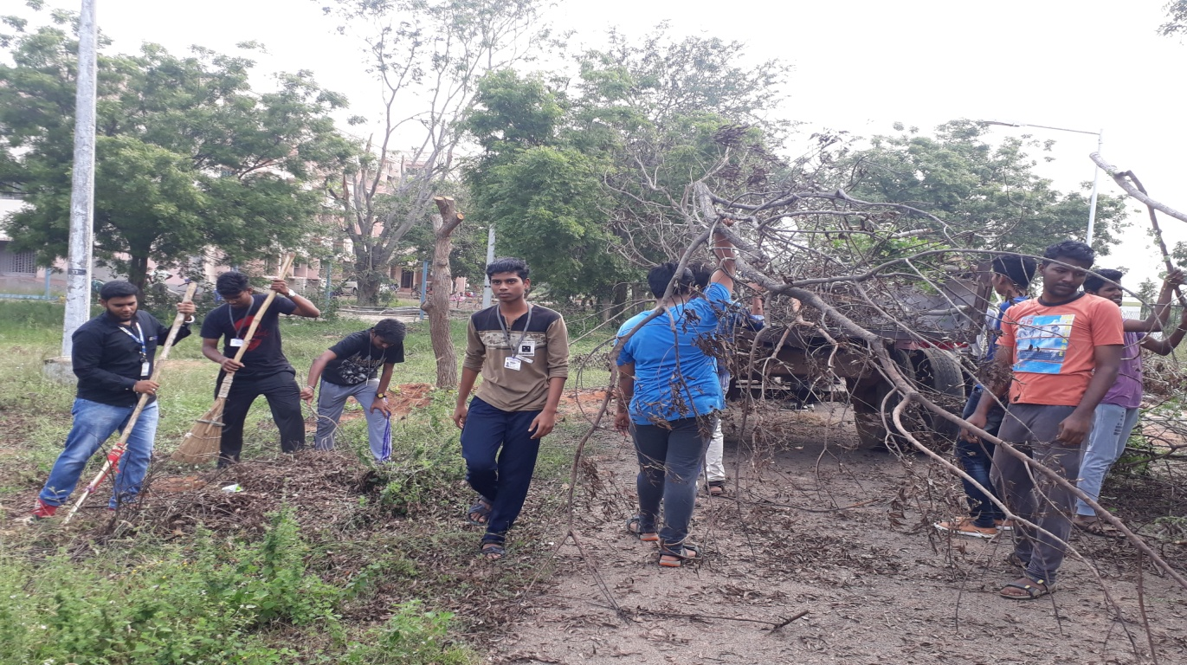

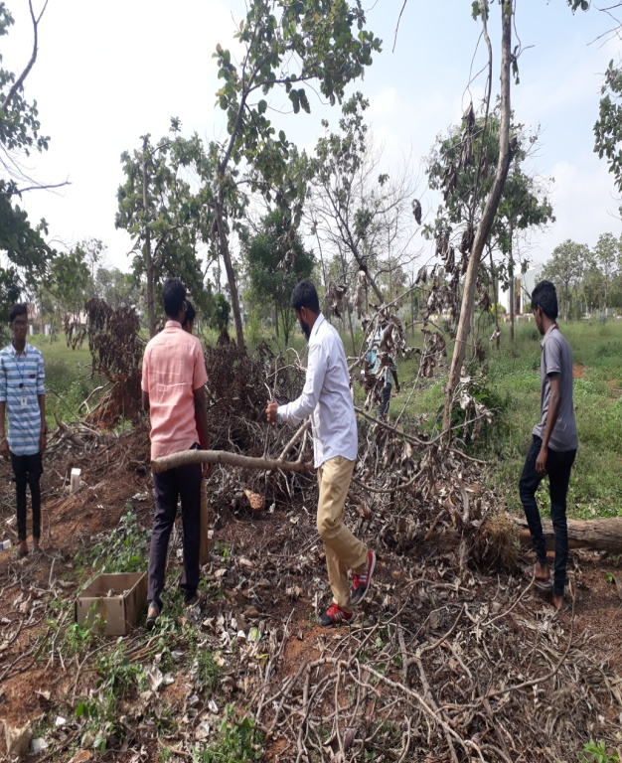

GAJA RELIEF FUND PROGRAMME

On the date of 13/12/2018 & 14/12/18, GAJA RELIEF FUND PROGRAMME was conducted by the NSS VOLENTEER’S in PUDUKOTTAI.
The programme was a mass success because of the co-ordinator of volunteers.
NO. OF PARTICIPANT :10 DATE : 18/12/18
VENUE : PUDUKOTTAI
HOUR:10 hrs TIME : 6.30 AM TO 9.30PM
CHIEF GUEST : BDU NSS CO ORDINATOR Dr. A.LAKSHMI PRABHA & ALLI RANI BALAJI

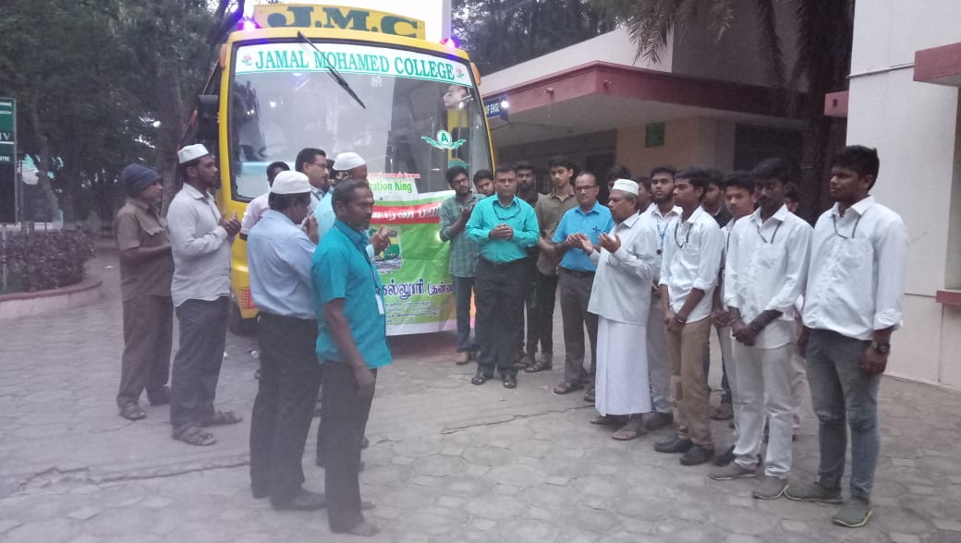
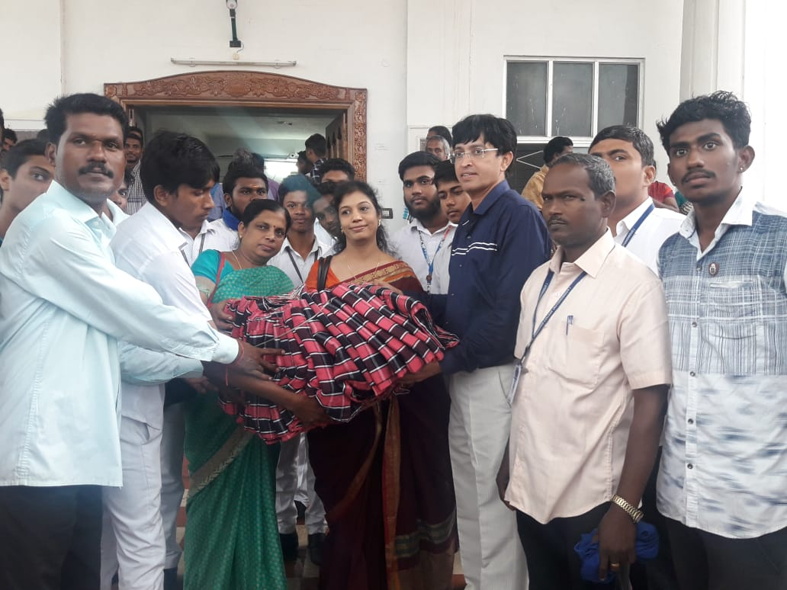

NSS AWARD CERMONY FUNCTION

On the date of 13/12/2018 & 14/12/18, NSS AWARD CERMONY FUNCTION was conducted by the NSS VOLENTEER’S in BDU.
The programme was a mass success because of the co-ordinator of volunteers.
NO. OF PARTICIPANT :10 DATE : 28/12/18
HOUR: 5 hrs TIME : 9:00 AM TO 2:00PM
CHIEF GUEST: BDU REGITAR GOBINATH
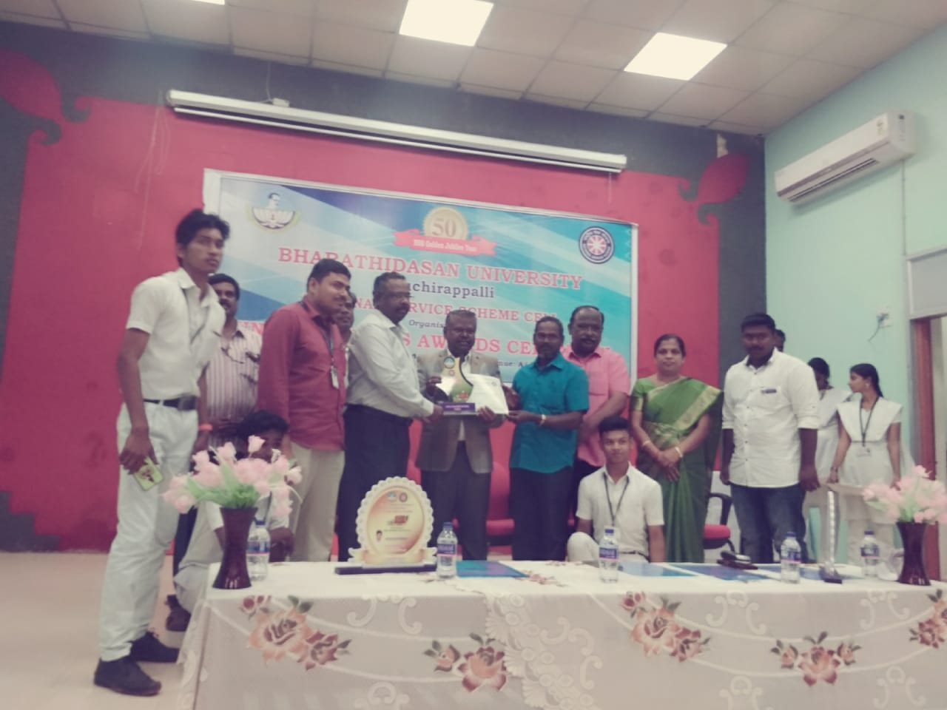

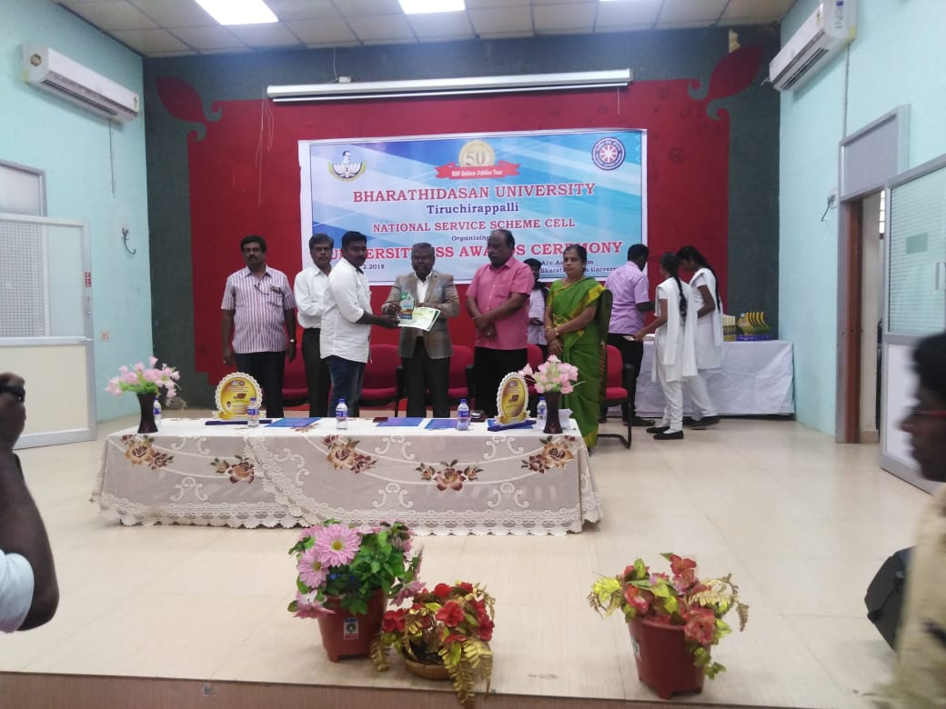

DIFFERENTIAL ABLE CHILDREN CAMP

On the date of 28/12/18 &29/12/18,DIFFERENTIAL ABLE CHILDREN CAMP was conducted by the NSS VOLENTEER’S in BDU.
The programme was a mass success because of the co-ordinator of volunteers.
NO. OF PARTICIPANT :10 DATE : 28/12/18 &29/12/18
VENUE : INFANT JESUS HOSPITAL
HOUR:9 Hrs TIME : 9:00 AM TO 6.00PM

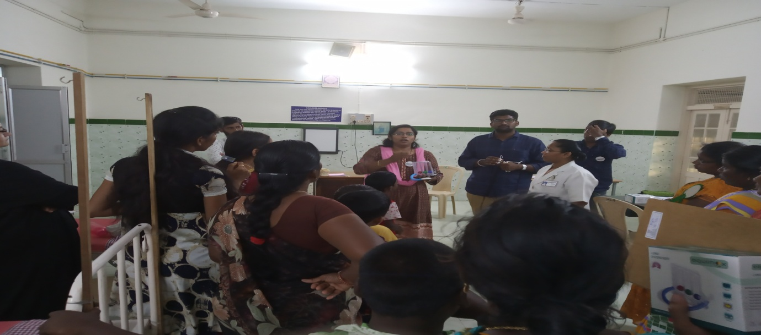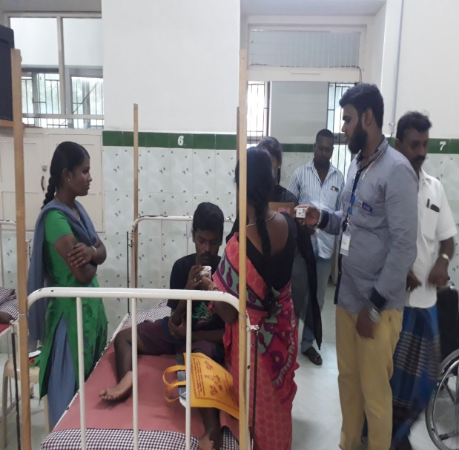
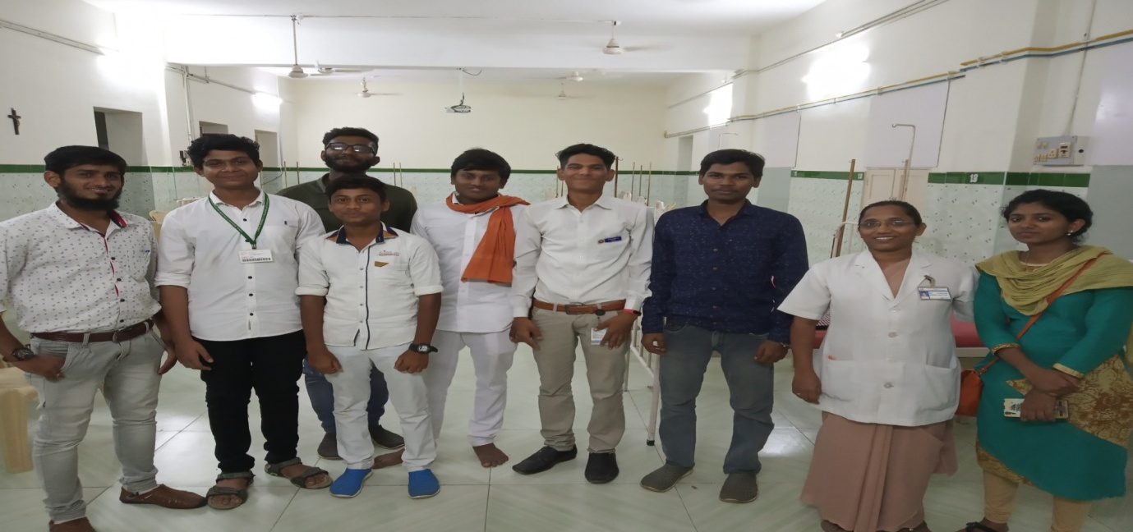

ELOCUATION PROGRAMME

On the date of 4/01/19,ELOCUATION PROGRAMME was conducted by the NSS VOLENTEER’S in BDU.
The programme was a mass success because of the co-ordinator of volunteers.
NO. OF PARTICIPANT :13 DATE : 4/01/19
VENUE : BDU
HOUR:3 hrs TIME : 9:00 AM TO 12:00PM
CHIEF GUEST: BDU NSS CO ORDINATOR Dr. A.LAKSHMI PRABHA
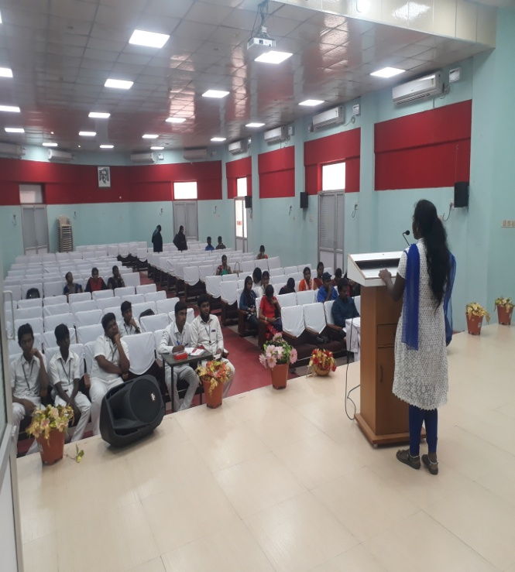. 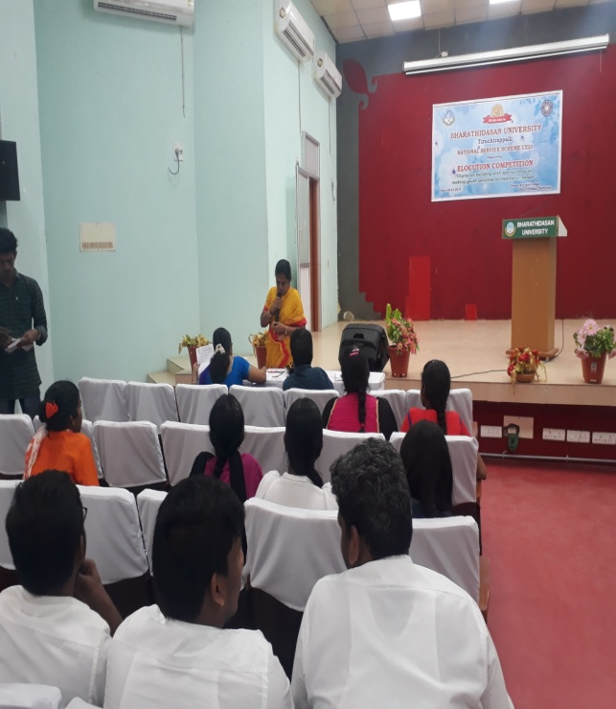
VOLS - SPL

On the date of 10/01/19, VOLS - SPL was participated by the NSS VOLENTEER’S in BISHOP HEBER COLLEGE.
The programme was a mass success because of the co-ordinator of volunteers.
NO. OF PARTICIPANT: 20 DATE: 10/01/19
VENUE: BISHOP HEBER COLLEGE
HOUR: 9 hrs TIME: 9:00 AM TO 6 PM
CHIEF GUEST: THIRUVALLUVAR UNVERSITY NSS CO ORDINATOR SENTHIL KUMAR
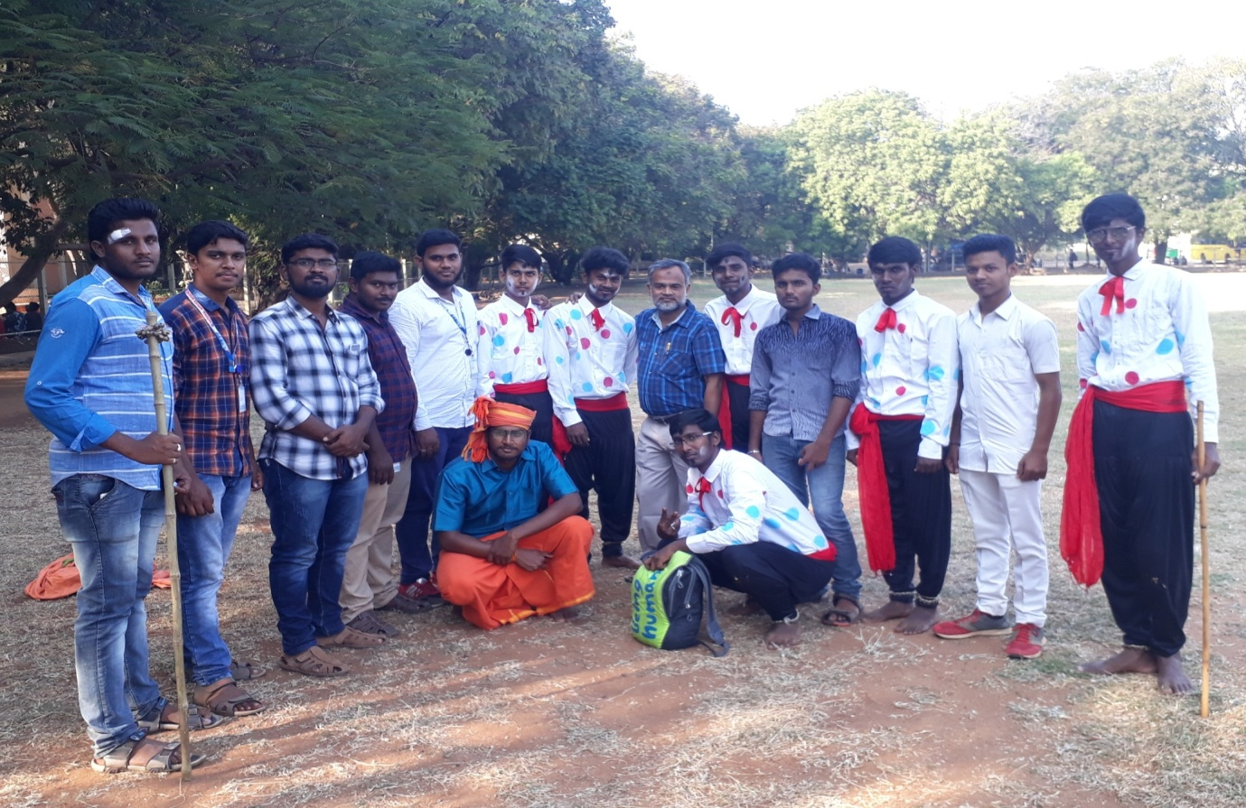

DISTRICT YOUTH PARLIMENT

On the date of 11, 12 /01/19 , DISTRICT YOUTH PARLIMENT was participated by the NSS VOLENTEER’S in JMC – Commerce gallery.
The programme was a mass success because of the co-ordinator of volunteers.
NO. OF PARTICIPANT: 10 DATE: 11,12/01/19
VENUE: JMC – Commerce gallery
HOUR: 9 hrs TIME: 08:30 AM TO 6.30 PM
CHIEF GUEST: Dr.M.KAMARAJ,Dr.M. ANWAR SADIQ & Mr.S.AKBAR ALI
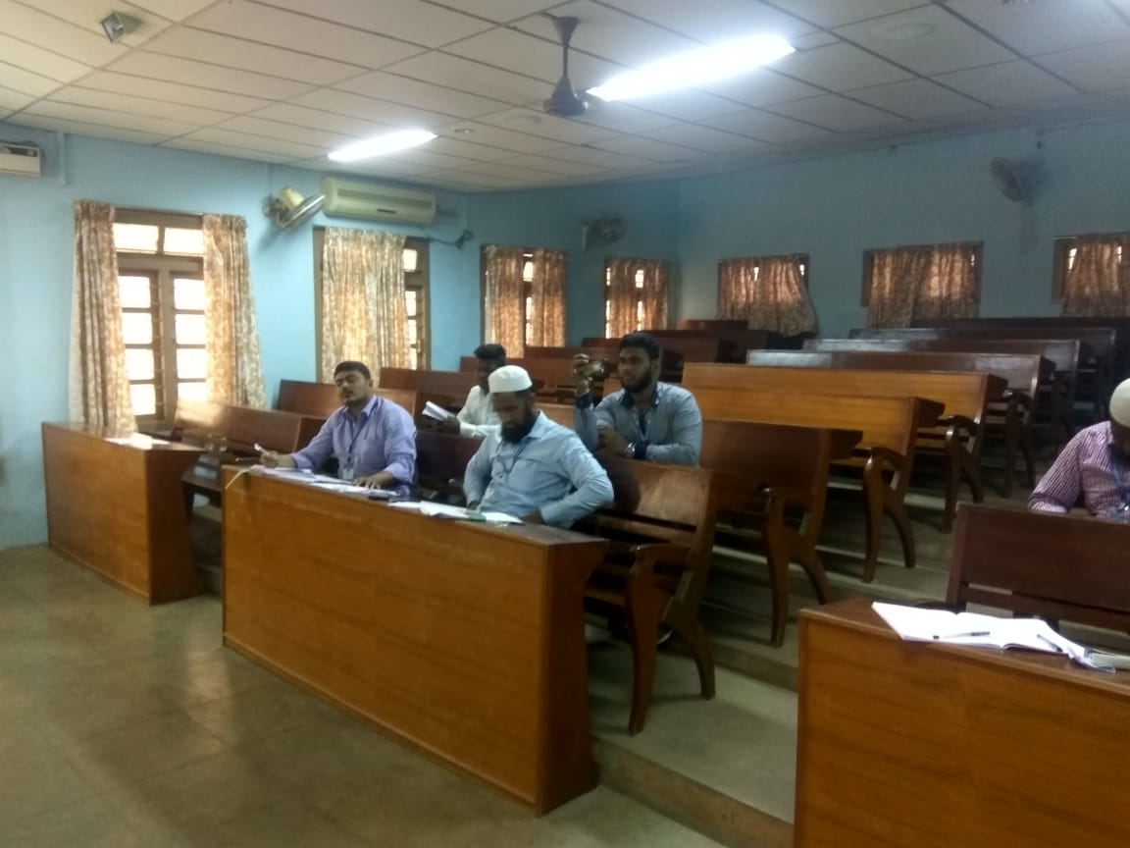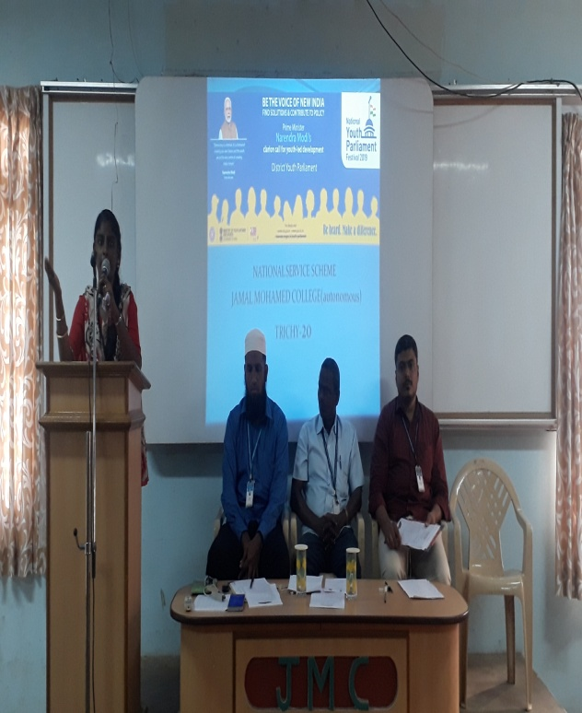

DISTRICT YOUTH PARLIMENT

On the date of 26/01/19, DISTRICT YOUTH PARLIMENT was participated by the NSS VOLENTEER’S in BDU.
The programme was a mass success because of the co-ordinator of volunteers.
NO. OF PARTICIPANT: 10 DATE: 26/01/19
VENUE: BDU
HOUR: 4 hrs TIME: 10:30 AM TO 02:30 PM
CHIEF GUEST : BDU VICE CHANCELLOR MANI SANKAR

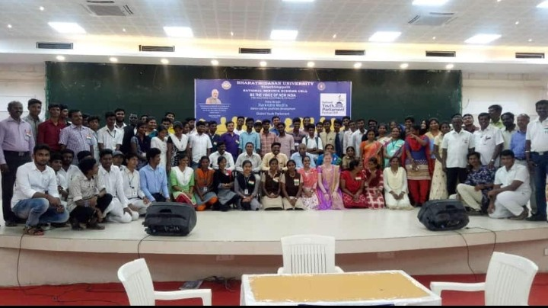

REPUBLIC DAY

On the date of 26/01/19 , REPUBLIC DAY was participated by the NSS VOLENTEER’S in JMC.
The programme was a mass success because of the co-ordinator of volunteers.
NO. OF PARTICIPANT: 30 DATE: 26/01/19
VENUE: JMC
HOUR: 9 hrs TIME: 08:30 AM TO 9:30 AM
CHIEF GUEST : MP. ABDUL RAHUMAN

REPUBLIC DAY

On the date of 26/01/19 , REPUBLIC DAY was participated by the NSS VOLENTEER’S in BDU.
The programme was a mass success because of the co-ordinator of volunteers.
NO. OF PARTICIPANT: 30 DATE: 26/01/19
VENUE: BDU
HOUR: 1hr TIME: 08:30 AM TO 9:30 AM
CHIEF GUEST : BDU VICE CHANCELLOR MANI SANKAR

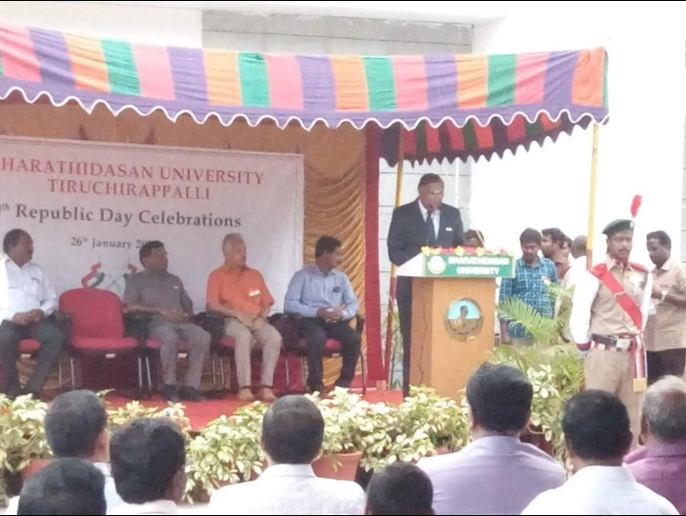

HUMANITY DAY

On the date of 30 /01/19, HUMANITY DAY was participated by the NSS VOLENTEER’S in SEMBATTU GOVT.SCHOOL.
The programme was a mass success because of the co-ordinator of volunteers.
NO. OF PARTICIPANT: 20 DATE: 30/01/19
VENUE: SEMBATTU GOVT.SCHOOL
HOUR: 3 hrs TIME: 12:00 PM TO 3:00 PM

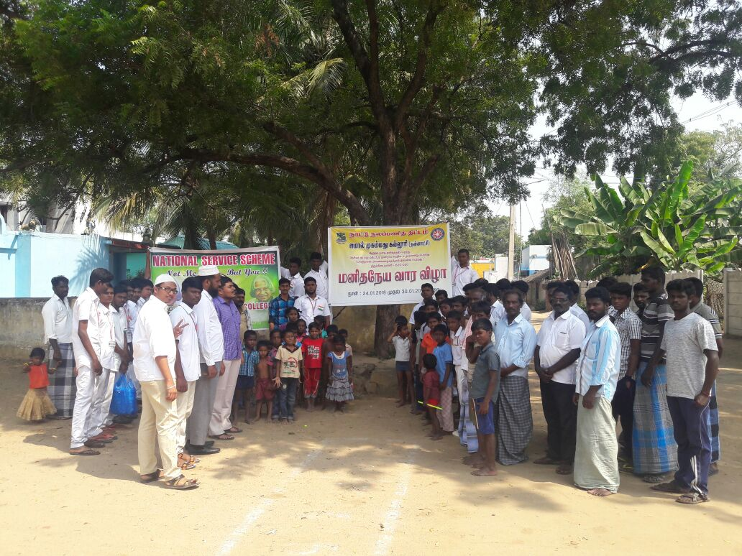

PULSE POLIO CAMP

On 10,11,12 March 2019 Pulse polio camp was conducted by city corporation. It was a mass success because of the co-ordinator of volunteers.
The programme was a mass success because of the co-ordinator of volunteers.
NO. OF PARTICIPANT: 30 DATE:10,11,12/01/19
VENUE: SUBRAMANIYAPURAM
HOUR: 11 hrs TIME: 6.00 AM TO 5:00 PM
CHIEF GUEST : SUBRAMNIYAPURAM GH
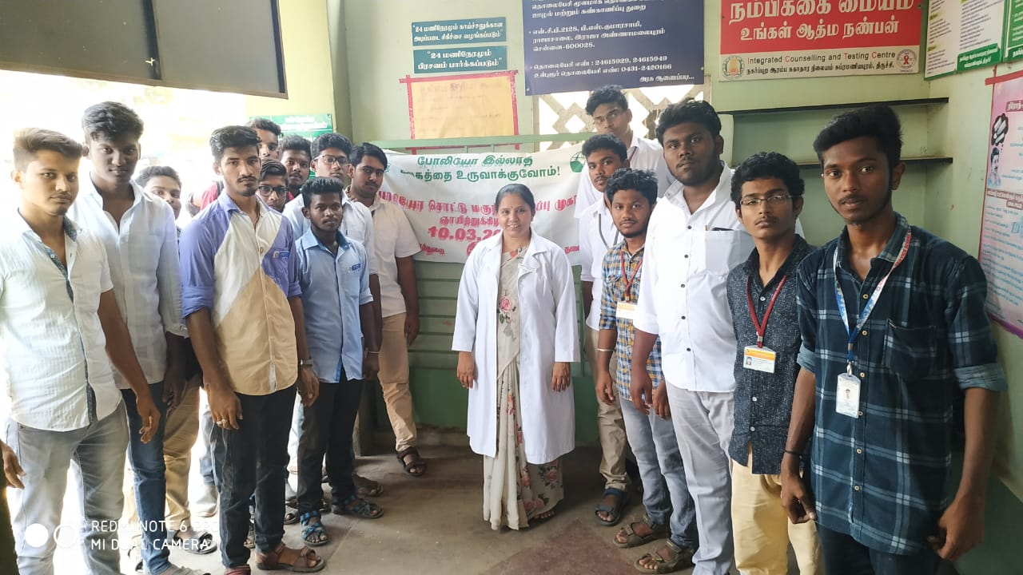

ONE DAY STATE LEVEL SEMINAR

On 21-03-19, One day state level seminar was conducted by the NSS VOLENTEERS in JMC. The programme was a mass success because of the co-ordinator and volunteers.
The programme was a mass success because of the co-ordinator of volunteers.
NO. OF PARTICIPANT:120 DATE: 21/03/19
VENUE: JMC
HOUR:9 hrs TIME:9.00AM TO 6:00 PM
CHIEF GUEST : Dr.A.ABDUL HAKEEM, Dr.SAMUVEL ANBU SELVAN,
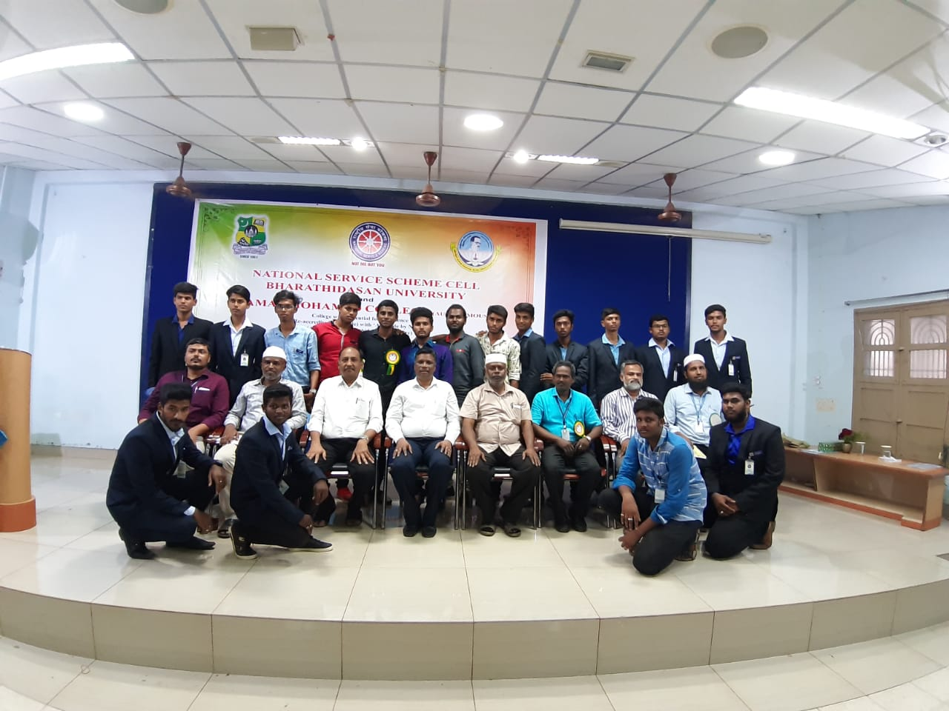

NATIONAL CAMP OF THE YEAR

- 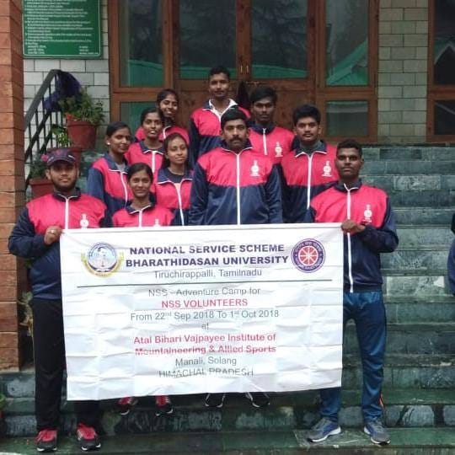
Name of the camp: ADVENTURE CAMP
Volunteer name : F. FAIZAL AHAMED
Date:22.9.2018 to 01.10.2018
Place: MANALI

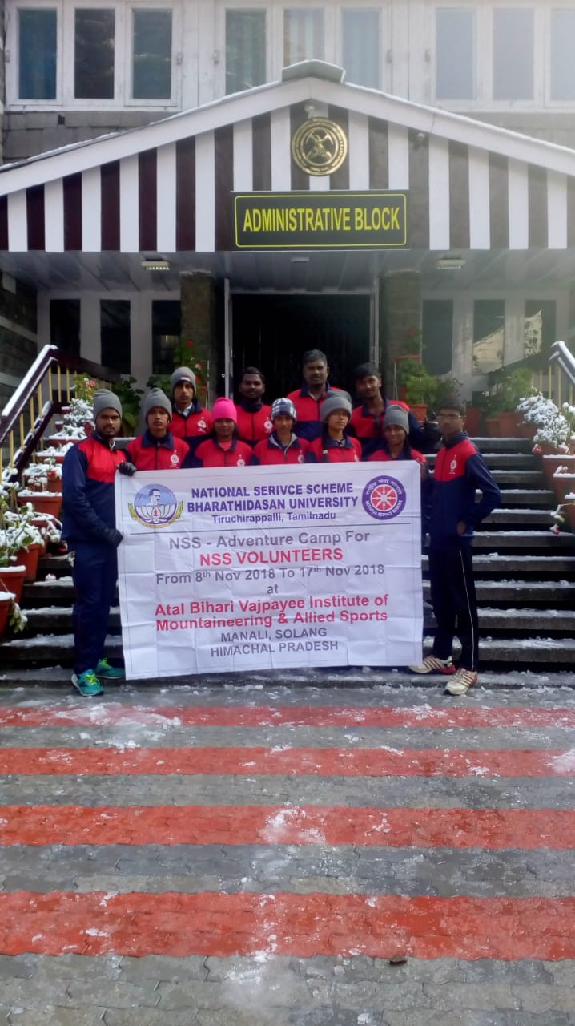
Name of the camp: ADVENTURE CAMP
Volunteer name: K.JEGADEESHWARAN
Date: 08.11.2018 to 17.11.2018
Place: MANALI

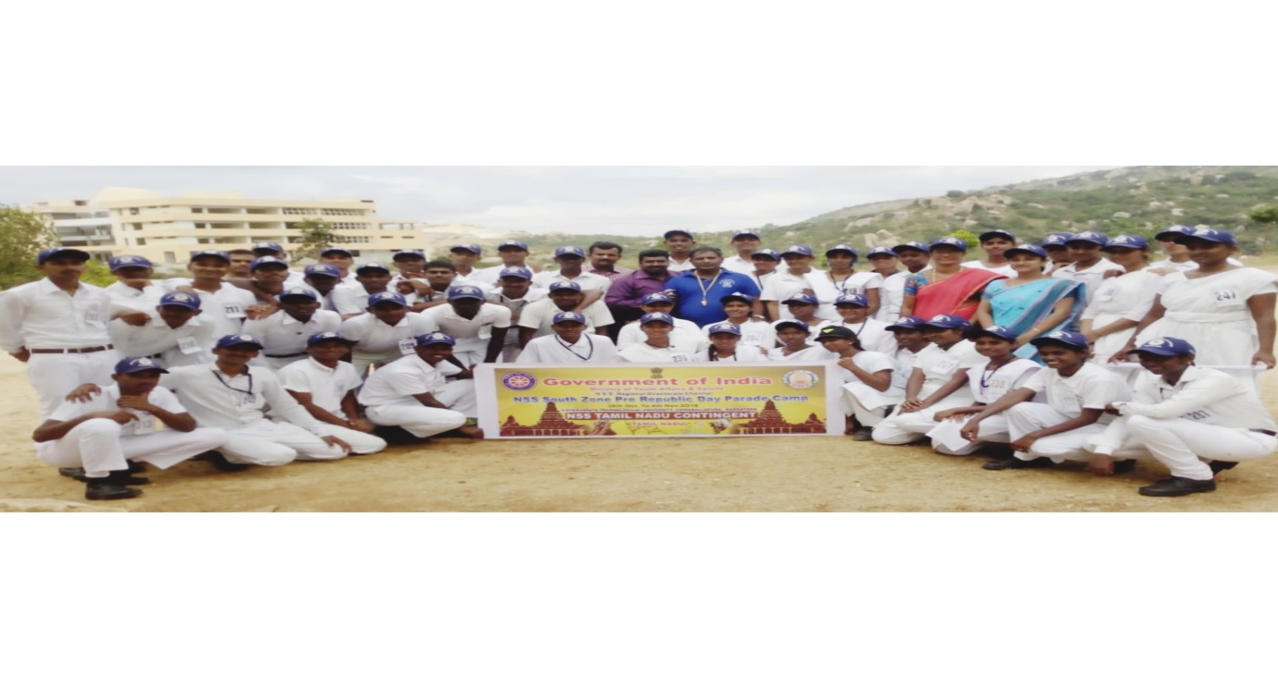
Name of the camp: SOUTH ZONE PRE-RD CAMP
Volunteer’s name: C. LEO JOHN & N.DEEPAN RAJ
Date: 26.10.2018 to 06.11.2018
Place: KARNATAKA

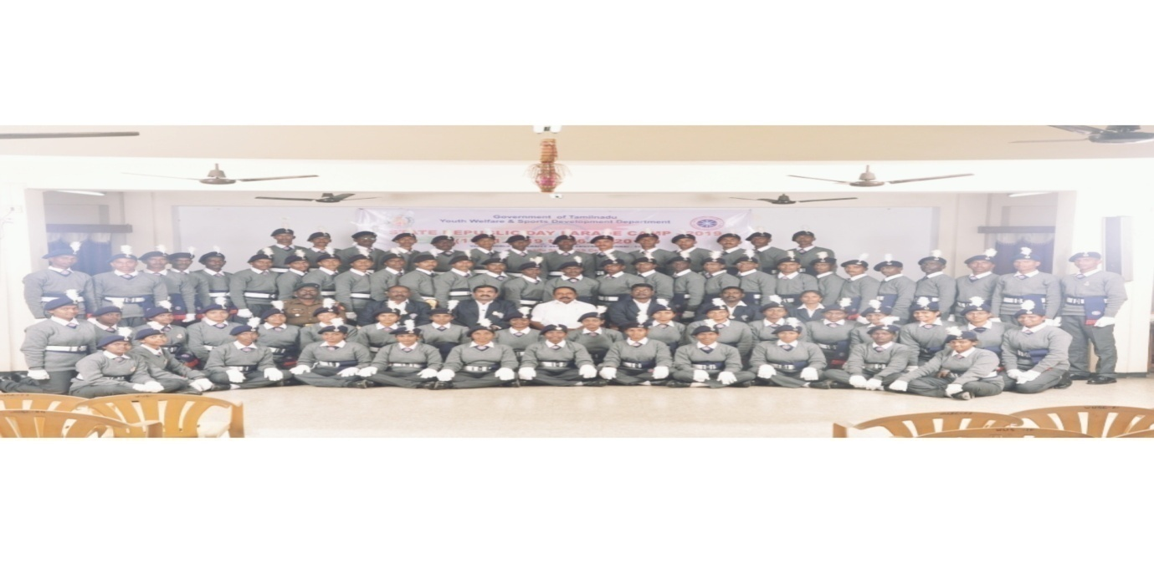
Name of the camp: STATE REPUBLIC DAY PARADE CAMP
Volunteer’s name: C. LEO JOHN & N.DEEPAN RAJ
Date: 16-01-19 to 26-01-19
Place: CHENNAI

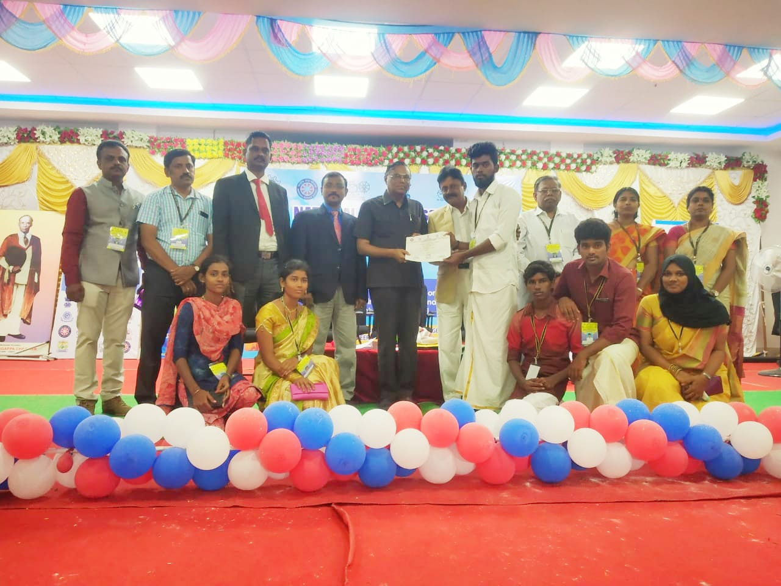

Name of the camp: NATIONAL INTEGRATION CAMP
Volunteer name : S. MOHAMED ASLAM
Date: 10.12.18 to 16.12.18
Place: KARAIKUDI

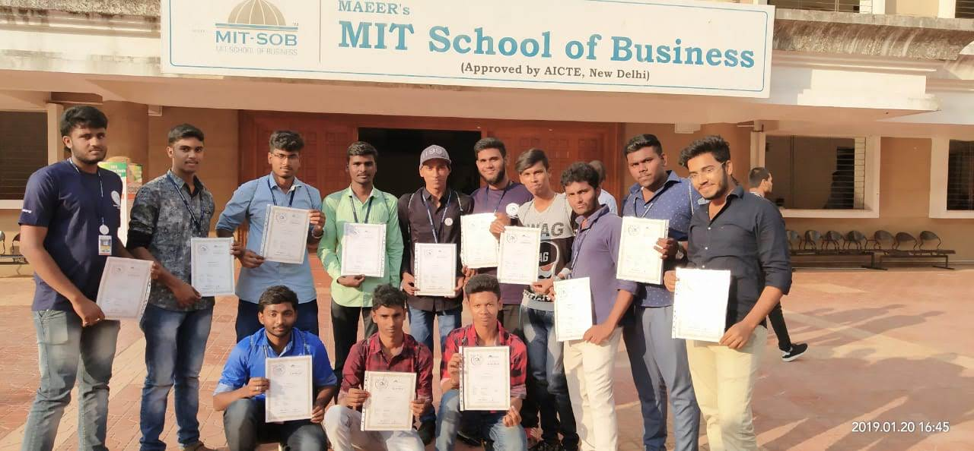
Name of the camp: INDIAN STUDENT PARLIAMENT CAMP
Date:21-01-19 to 23-01-19
Place: PUNE

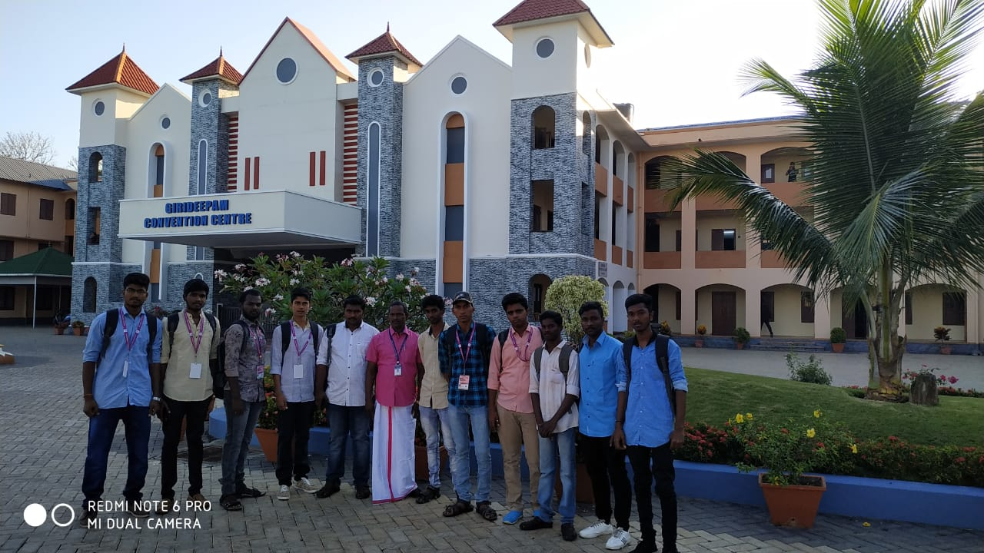

Name of the camp: NATIONAL STUDENT PARLIAMENT
Date: 22-02-19 to 26-02-19
Place: KERALA

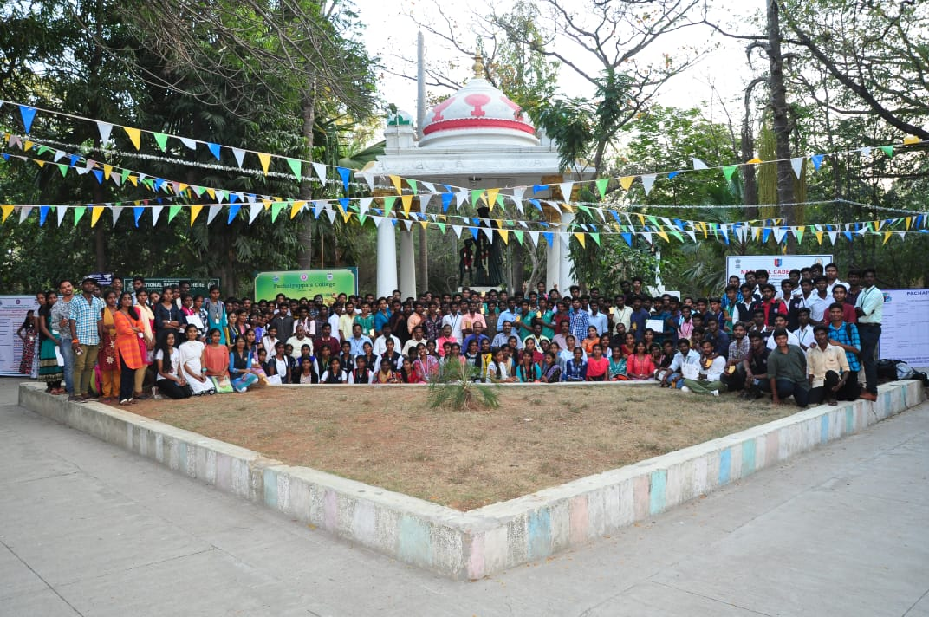

Name of the camp: STUDENT LEADERSHIP SEMINAR CAMP
Volunteer’s name: K. KARUPASWAMY &
S.PARTHIBAN
Date: 09.03.2019 to 10.03.2019
Place: CHENNAI

